Virginia Benefit Programs (BPRO)
BPRO members Only
Registration for LEAN Conference
DATE: September 28, 2017

NAME:________________________________________________
AGENCY/FIPS_________________________________________
RETURN: eburgess@vbgov.com or Deana.Bennett@dss.virginia.gov
Confirmation letters will be sent out following registration.

Please select one of the following BPRO Positions:
BPRO Member BPRO Board Member BPRO Committee Chair

The five Virginia Tech Locations are listed below.

Abingdon Arlington
1 Partnership Circle 900 North Glebe Road
Abingdon, VA 24212 Arlington, VA 22203

Newport News Richmond
600 Thimble Shoals Blvd 2810 N Parham Road, Suite 300
Newport News, VA 23606 Richmond, VA 23294
Seating is limited
Don’t Delay sign up today

Roanoke
108 N Jefferson Street
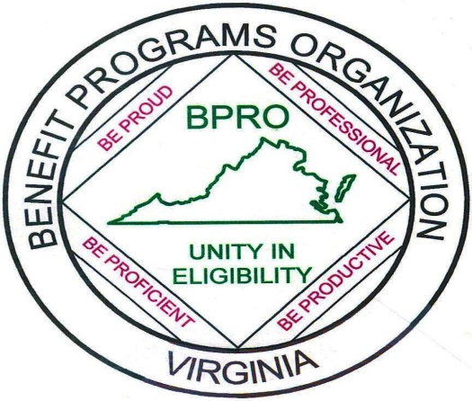
Roanoke, VA 24016

