CommonHelp Training

Our CommonHelp website allows individuals to apply for Medical Assistance, SNAP, TANF, Energy Assistance and Child Care. The website is customized to provide individuals the opportunity to upload documents during the application process.
Let’s discuss the various ways an individual may apply for benefits:
- Use the CommonHelp website: CommonHelp.virginia.gov/access
- Call the Enterprise Customer Service Center (ECSC) at 1-855-635-4370, Monday - Friday 8am – 7pm, Sat 9am-Noon
- Call the Cover Virginia Call Center at 1-855-242-8282, Monday – Friday 8am - 7pm, Sat 9am-Noon
- Visit a Local Department of Social Services to use a Kiosk and apply using the CommonHelp website
- Fill out a paper application and submit it to their Local Department of Social Services
- Visit the Federal Market place and submit an application (Medical Assistance applications only)

The below links provide more details and resources for our community partners:
https://www.vhcf.org/for-those-who-help/resources-for-providers/child-health-insurance-resources/on-demand-training/
www.coverva.org
After an application has been submitted and the local department of social services has completed eligibility review, the applicant receives a Notice of Action stating their case has been approved. Once they have received an approval notice, they may link their CommonHelp account to their case. (Only approved cases may be linked.)
Linking the account will allow individuals to:
- Report Changes,
- Check Benefits,
- Renew Benefits.
For the purposes of this training we will focus on - How to apply for Medical Assistance from the CommonHelp website: http://commonhelp.dss.virginia.gov/

Contents
ACCESSING THE COMMONHELP WEBSITE 4
CREATE A NEW ACCOUNT 7
BEGIN THE APPLICATION PROCESS 9
IDENTITY PROOFING 13
WHO IS COMPLETING THE APPLICATION 15
QUESTIONS ABOUT THE APPLICANT(S) 18
TAX RETURN DETAILS 29
EMPLOYMENT AND SELF EMPLOYMENT 35
MONEY FROM OTHER SOURCES 38
ADDITIONAL INFORMATION 40
ATTACHING DOCUMENTS 41
AUTHORIZED REPRESENTATIVE 42
CERTIFIED APPLICATION COUNSELOR/NAVIGATOR/BROKER 43
SIGNING YOUR APPLICATION 45
ADDITIONAL RESOURCES 48

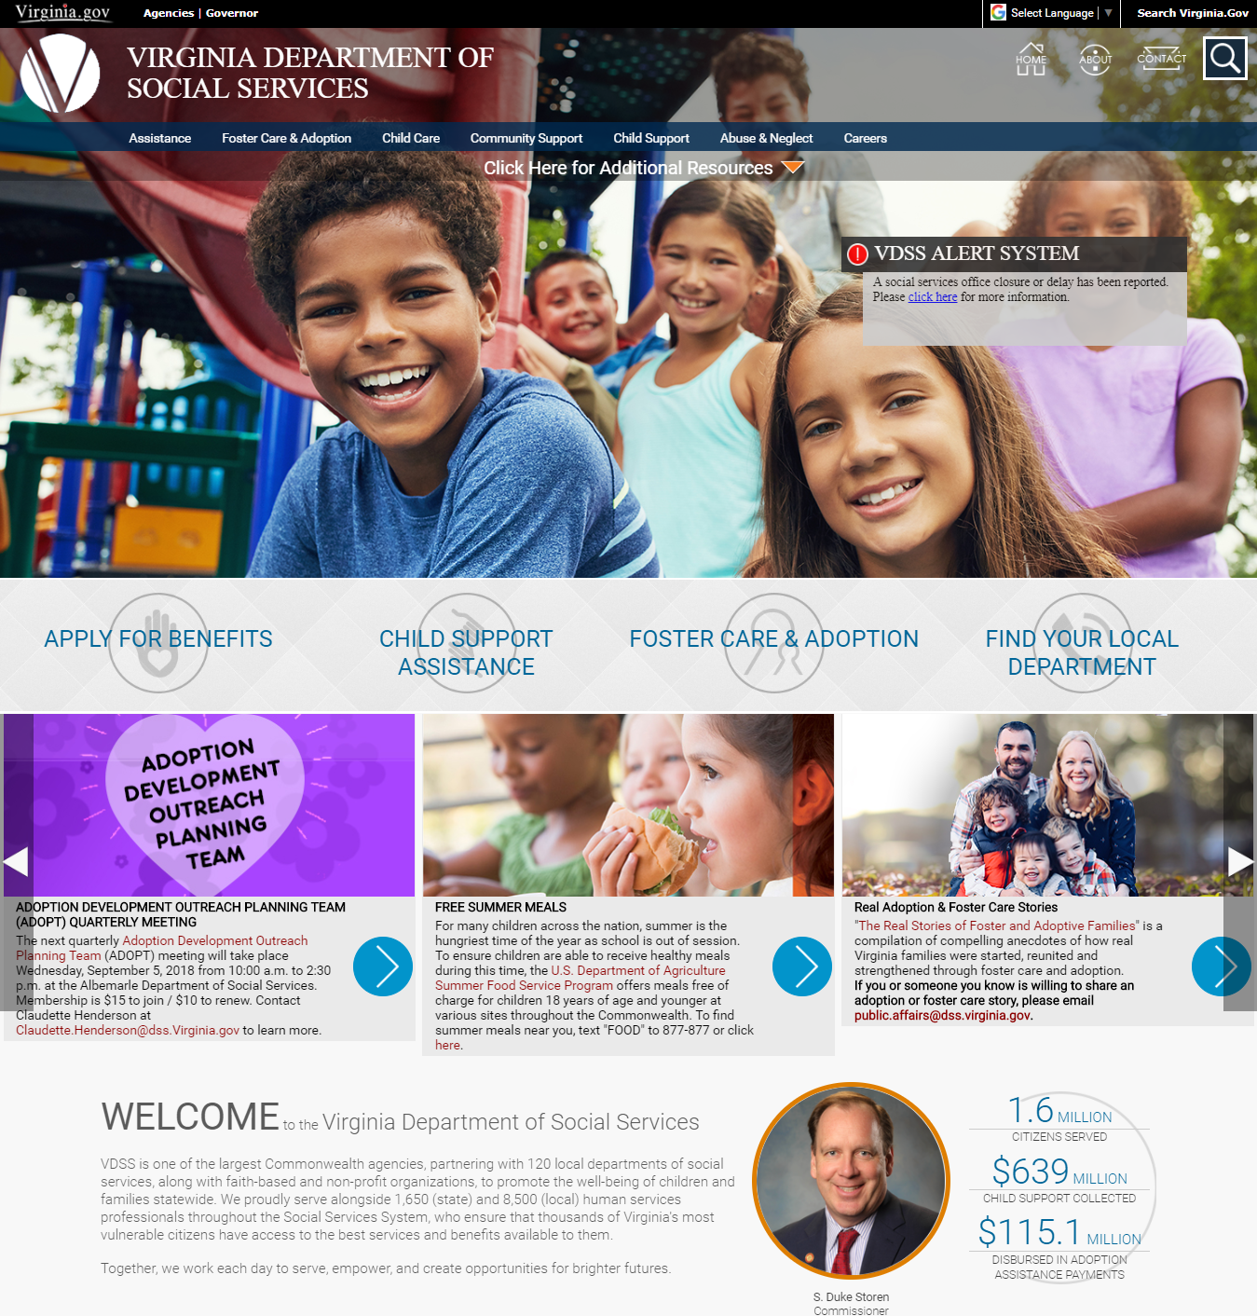

ACCESSING THE COMMONHELP WEBSITE
From our public website: www.dss.virginia.gov, you will click on the below image - “Apply for Benefits”.
When the below screen displays, select “Apply Online Using CommonHelp”.
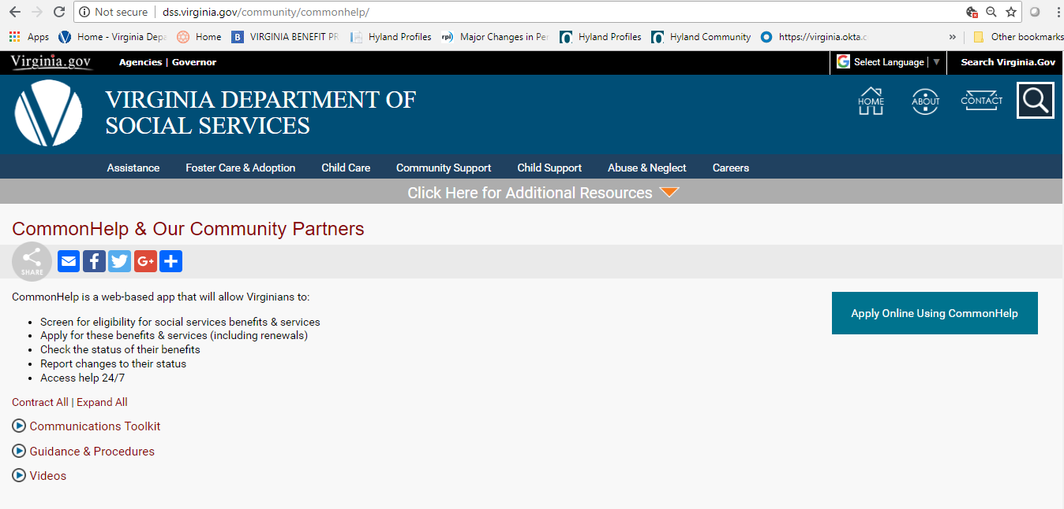

The CommonHelp site will display two choices:
- You may apply for just Medical Assistance by choosing “HEALTH CARE ONLY” or
- Apply for all benefits by selecting “ALL BENEFIT PROGRAMS”

We will select the HEALTH CARE ONLY option.
Depending on the above choice, workers will see where the question about resources is been asked on the submitted application.
Click on “Get Started” under HEALTH CARE ONLY option.

CREATE A NEW ACCOUNT
You will need to create an account for the applicant. Use the individual’s driver’s license or legal birth certificate to obtain the correct spelling of their First and Last Name.
Keep in mind that accounts should not be set up in a minor’s name, please use the parent’s name. An email address is required to confirm account set up. (Parents are not required to apply for benefits but must be listed as part of the household.)
Note: If you are an Authorized Representative, Legal Guardian or Power of Attorney, you should set up the CommonHelp account in your Legal First and Last Name, not the applicant’s. Fill out all the below fields and click SUBMIT.
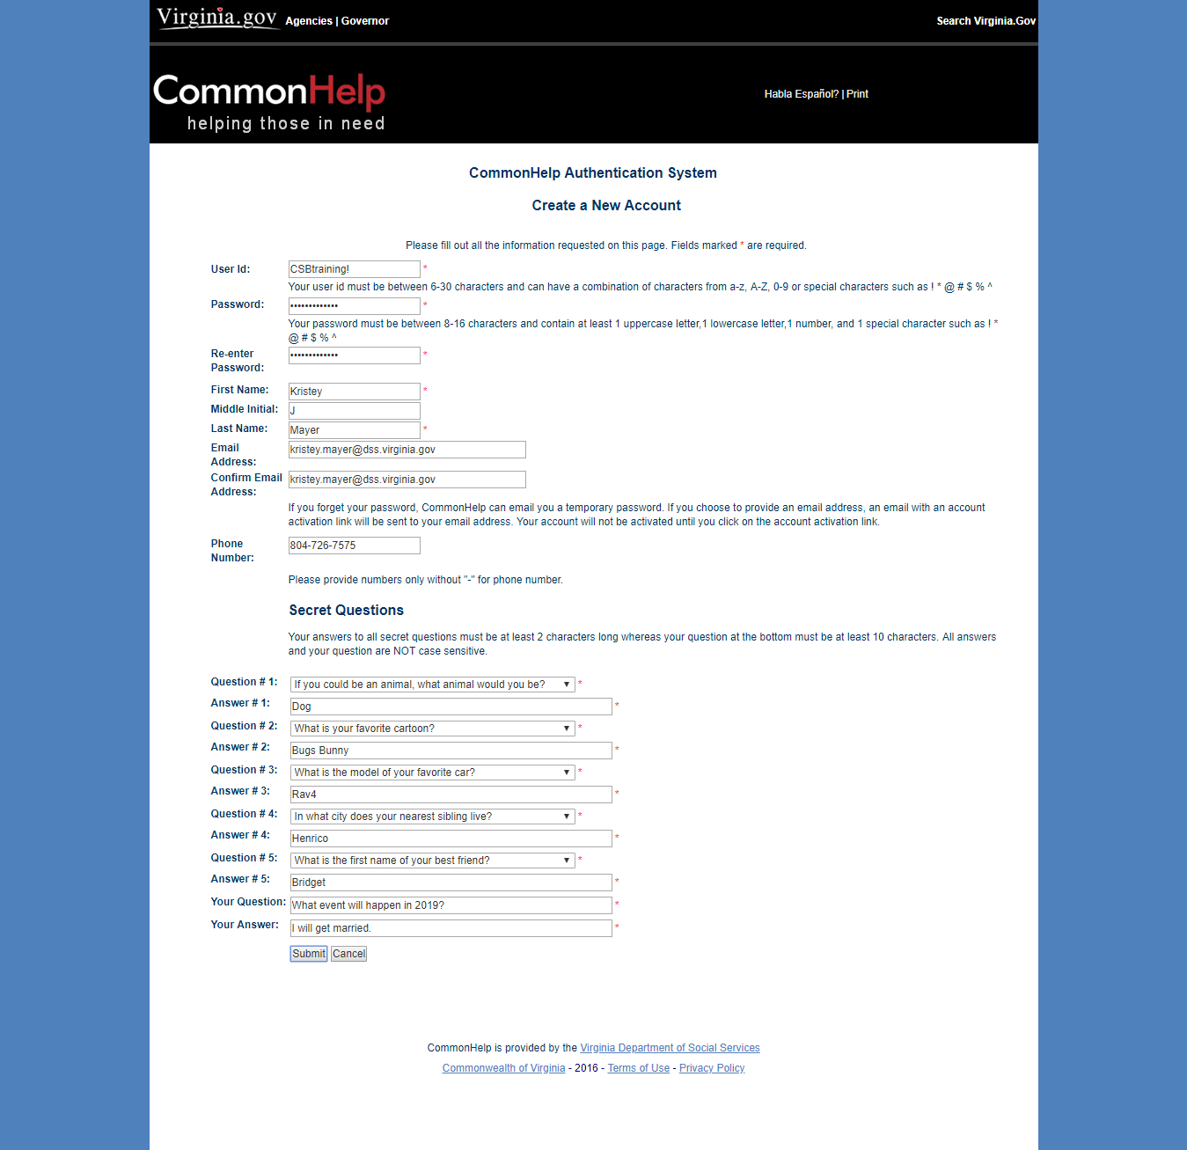
The applicant will be emailed a hyperlink to activate their account. (Example shown below.) The application cannot be started until account activation has been completed.
Note: This account is owned by the applicant. Make sure to tell the applicant to change their password after the application has been successfully submitted.
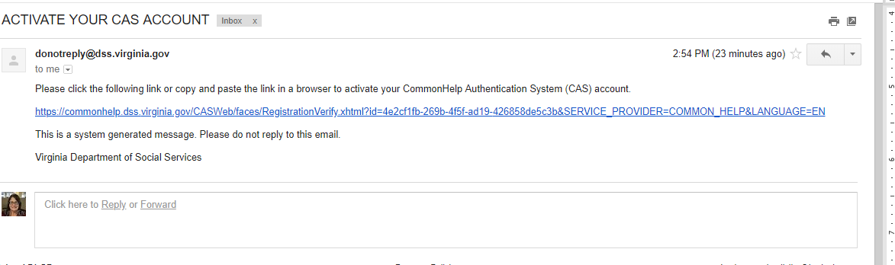
Once the applicant has clicked on the above link, they will see the below confirmation screen.
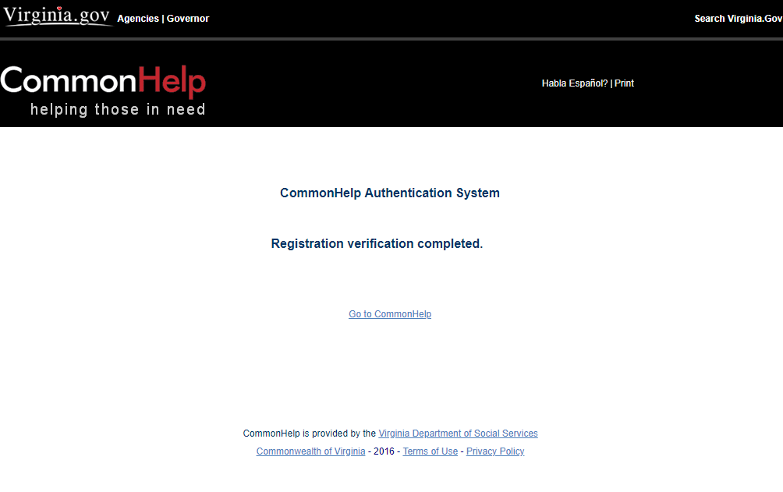

BEGIN THE APPLICATION PROCESS
Choose the hyperlink “Go to CommonHelp” and log in or go back to our website at www.dss.virginia.gov and choose “APPY for Benefits”. Choose the HEALTH CARE ONLY option, Get Started button. Enter the individual’s user id on the screen below and select LOGIN.
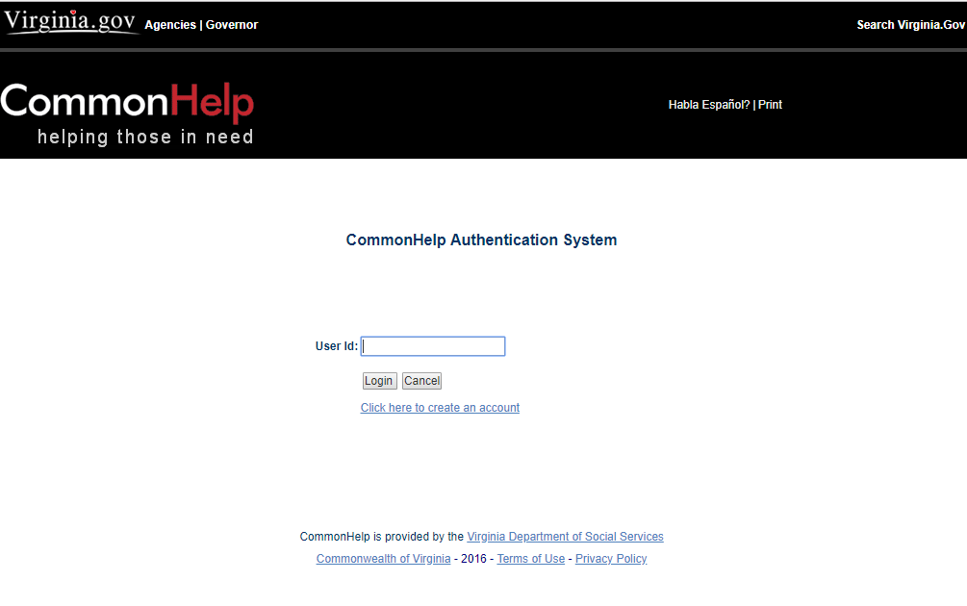

Enter the account password on the below screen and select LOGIN.
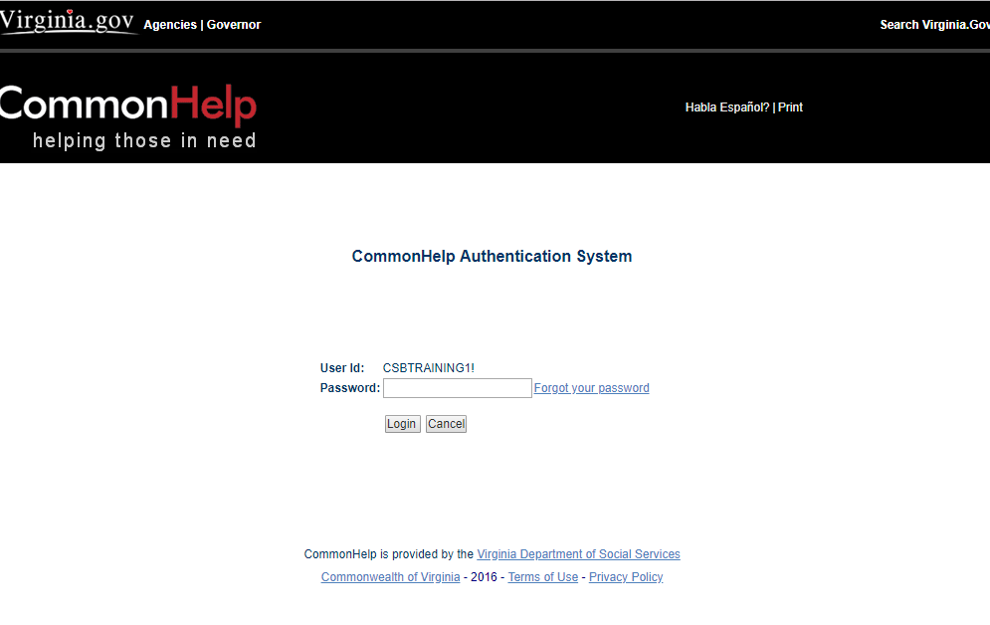

You will need to accept the Confidentiality Agreement on the below screen. Click - I ACCEPT.
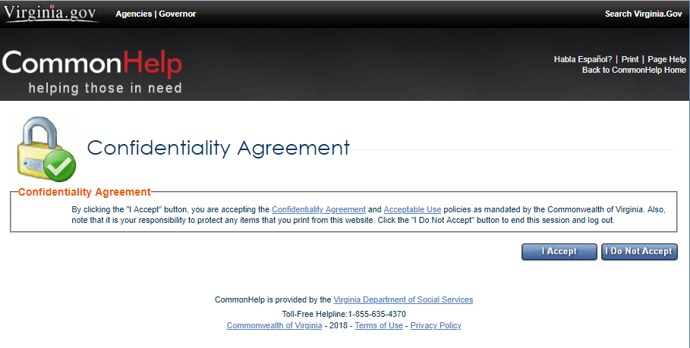

You will be asked if you wish to begin a new application or to restart an application you began and did not finish. Choose “Start a new application for Health Care Coverage (Medicaid or FAMIS)” and select NEXT.
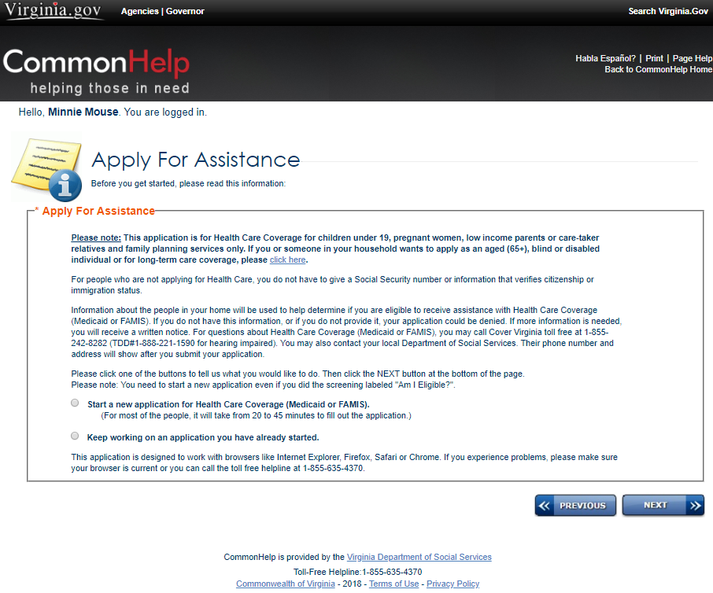

IDENTITY PROOFING
The below screen may allow some individuals to receive a decision at the end of the application process if they have passed the identity proofing process and are found eligible. Note: If the applicant has a block on their Equifax or Experian account, you should skip this proofing process.
We will not be completing these screens. Choose “I would like to skip the Identity proofing process”.
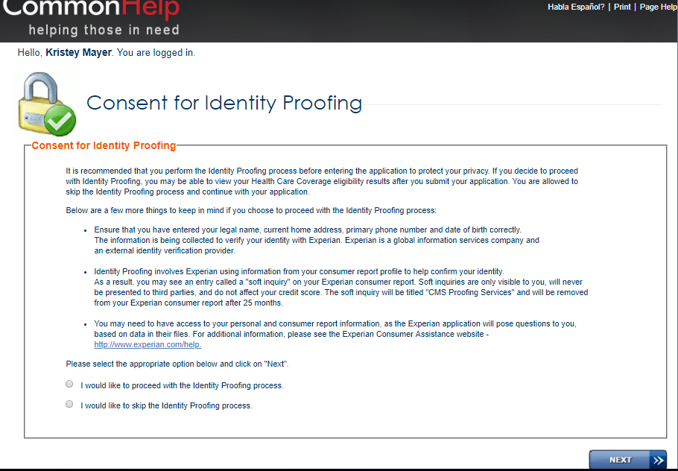

You will see a warning message display after we choose to skip the process. You will need to click on NEXT.

Information about the application process will display. Please read this page and make sure you have access to the information that will be requested. Click Next
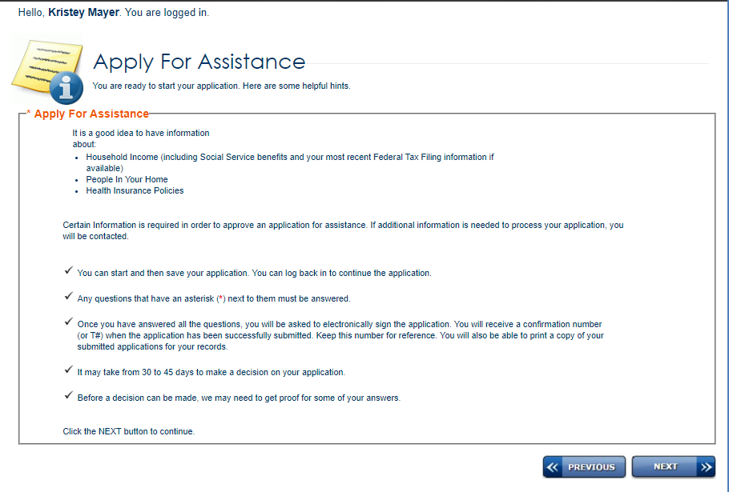

WHO IS COMPLETING THE APPLICATION
Let’s spend some time discussing the below screen.
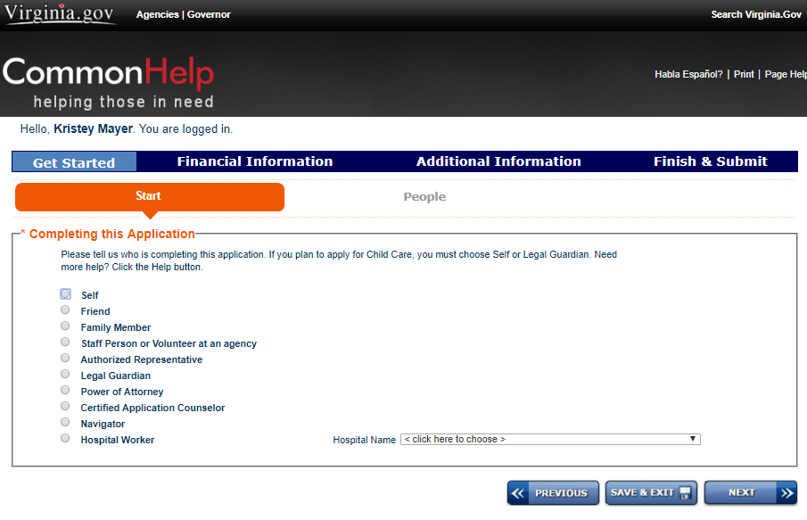
Who is applying? | ACCOUNT SETUP | Your Contact Information Required?
Self | Must be set up with applicant's name. | No
Friend | Must be set up with applicant's name. | Yes
Family Member | Must be set up with applicant's name. | Yes
Staff Person or Volunteer at an agency  *recommend using this for checklist purposes | Must be set up with applicant's name. | Yes
Authorized Representative | Must be set up with Authorized Representative legal name. | Yes
Legal Guardian | Must be set up with Legal Guardian’s legal name. | Yes
Power of Attorney | Must be set up with Power of Attorney legal name. | Yes
Certified Application Counselor | Must be set up with applicant's name. | Yes
Navigator | Must be set up with applicant's name. | Yes
Hospital Worker | Must be set up with applicant's name. | No

DEFINITIONS
Self – Choose this option if you are applying for yourself and your immediate family members.
Friend – Choose this option if you are assisting someone to apply for benefits. You will not be added to the application. The applicant will be contacted by the local department of social services as the applicant is required to sign the application before benefits can be determined.
Family Member – Choose this option if you are assisting a family member to apply for benefits.
Staff Person or Volunteer at an agency – Choose this option if you volunteer or are employed by a Local Department of Social Services Agency.
Authorized Representative – Choose this option if the applicant has provided you with written approval to submit applications, renewals, change requests and to receive information on their behalf. You will be able to associate this account to the applicant’s case.
Legal Guardian – Choose this option if you have been appointed as the legal guardian. You will need to be able to provide written documentation of this status.
Power of Attorney – Choose this option if you have been appointed as Power of Attorney. You will need to be able to provide written documentation of this status.
Certified Application Counselor – An individual (affiliated with a designated organization) who is trained and able to help consumers, small businesses, and their employees as they look for health coverage options through the Marketplace or CommonHelp, including helping them complete eligibility and enrollment forms. You will be able to associate this account to the applicant’s case.
(See https://marketplace.cms.gov for more information on this topic.)

Navigator – The law lists a number of different kinds of entities that could become navigators, including:
- community- and consumer-focused nonprofits;
- trade, industry, and professional associations;
- commercial fishing, ranching, and farming organizations;
- chambers of commerce;
- unions;
- Small Business Administration resource partners;
- licensed insurance agents and brokers; and
- other entities.
(See https://marketplace.cms.gov for more information on this topic.)

Hospital Worker – You may choose this option if you are staff that work at a hospital but are employed by a Local Department of Social Services Agency.

In this example, Navigator was selected. You will need to enter your contact information on the below screen.
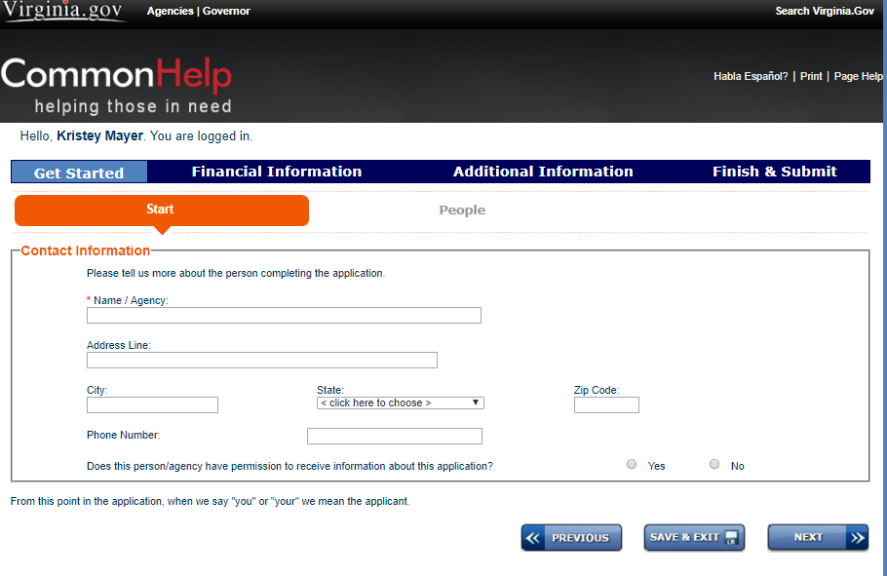
Note: when you see the option to SAVE & EXIT, this will allow you to save your application to come back and finish at a later time. This action will not submit the application for consideration.

QUESTIONS ABOUT THE APPLICANT(S)
From this section forward, all questions will be related to the applicant(s).
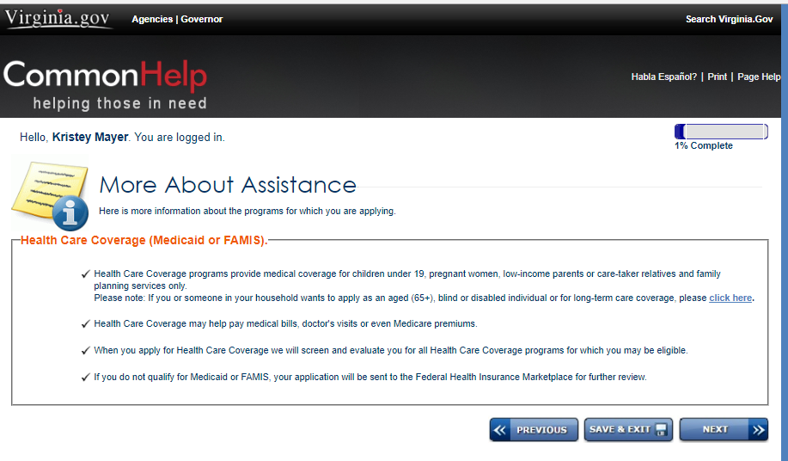

Enter in the information for your applicant. (The individual’s name used during account set up should display. If your name displays, you will need to click on the PREVIOUS button to go back and correct your answer to “Who is submitting the application?”) Enter the individual’s address prior to incarceration.

Enter the following under mailing address: 6900 Atmore Drive, Richmond Virginia 23225. You may enter your contact information in the Contact section.

After each section a summary screen will display. Make sure you review all details. If any changes are needed, click on the “Change” icon to make your corrections. To expedite this training, screen shots of each summary section will not be shown.
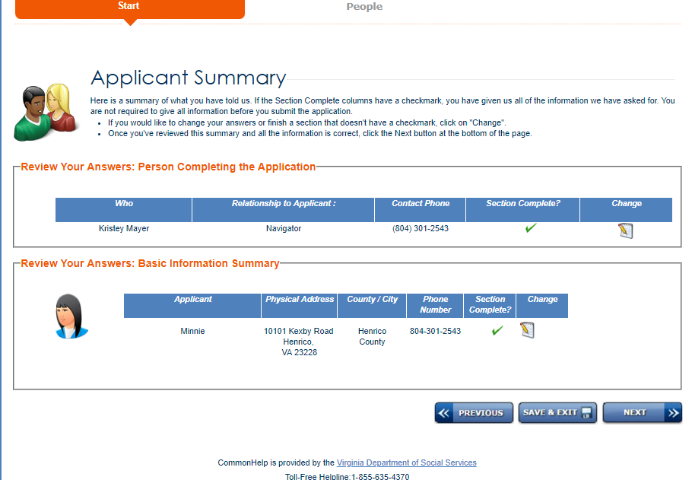

On the below screen, you can remove the program selection checkmark for individual(s) that are part of the household but do not wish to apply for benefits.
Complete the information for Race, Other Information, Temporarily away from home and the number of people in the home (The number you enter should include the applicant). If the individual is not applying for assistance, remove the checkmark in this section – “Program selection”. Do this for each person in the household that is not applying.

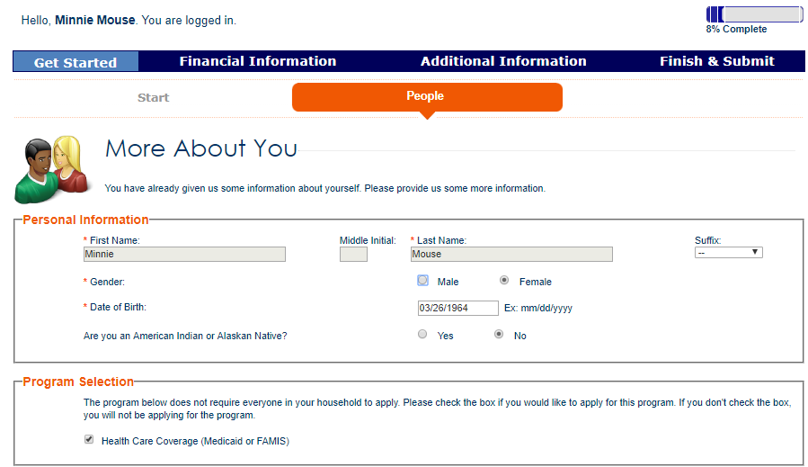

Complete the below sections for the individual.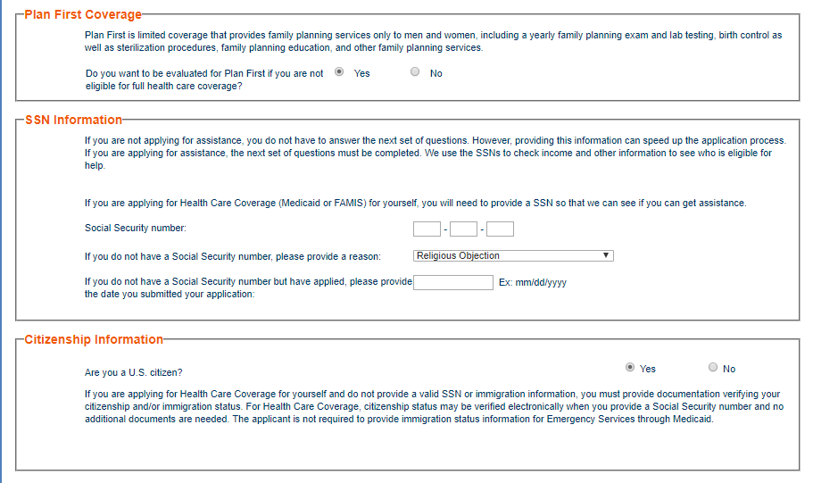
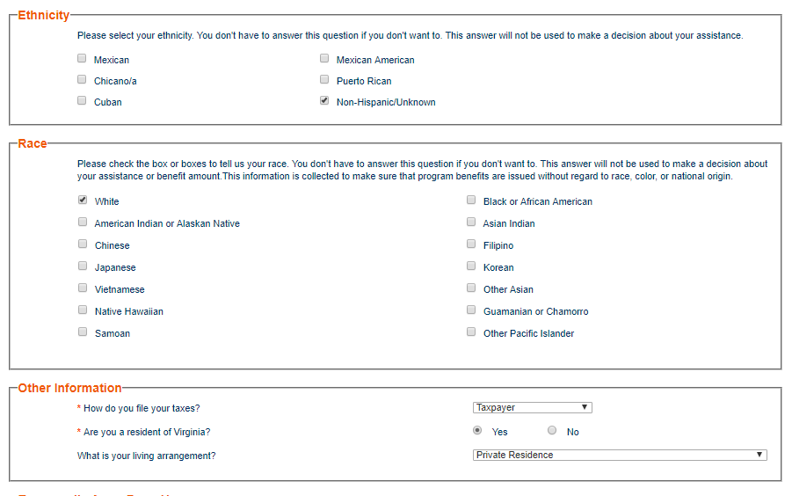

Complete the below sections for the individual and select NEXT.
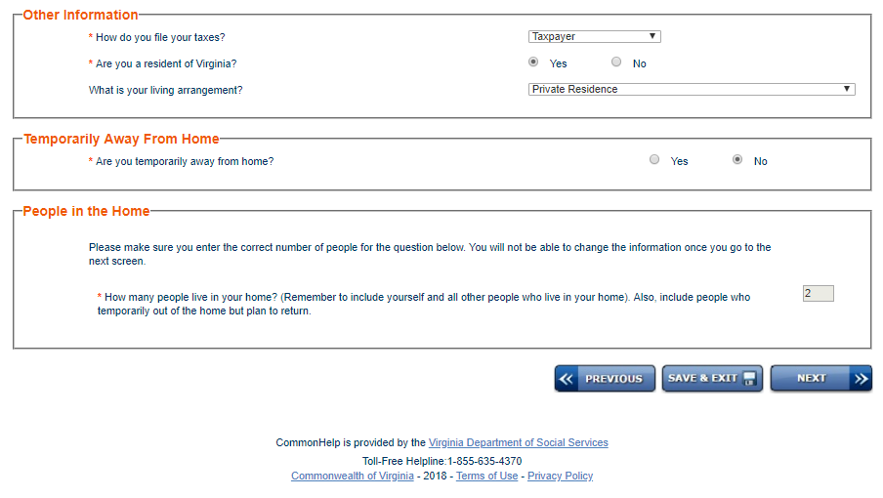

You will now enter details for the second person in the home. Note: You will be presented a screen for each individual based on the household count you entered on the previous screen.
Select the answers for the questions listed below.
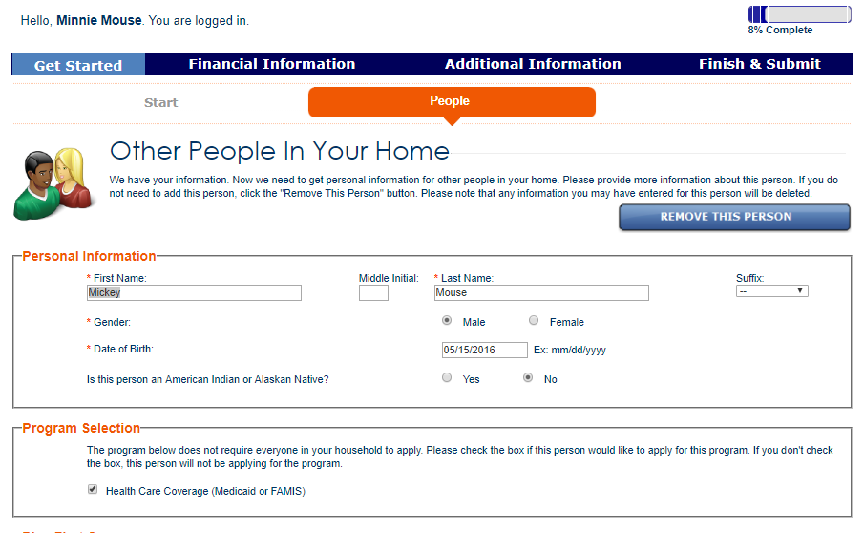

Select the answers for the questions below.

Select the answers for the questions below.

Choose the correct relationship between all household members. This screen will display all individuals listed on your application and a relationship will need to be chosen for each person and how they are related to each person on this application.
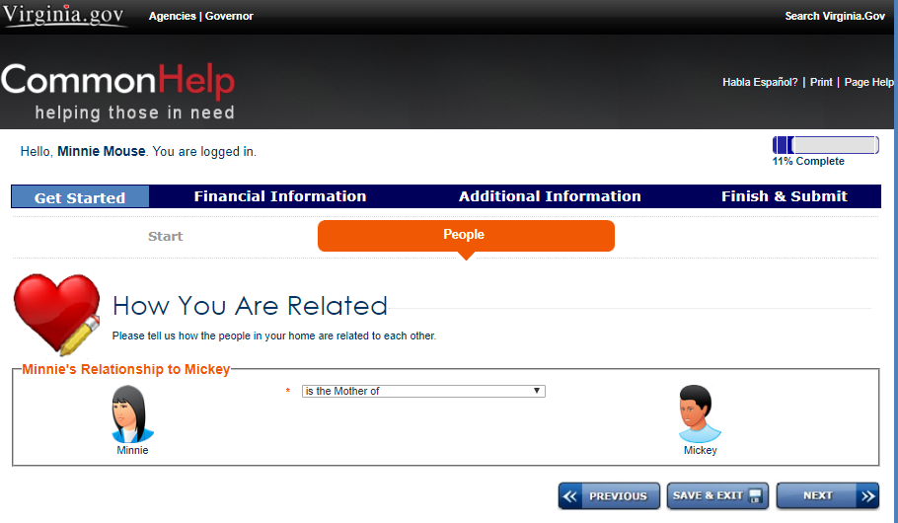

TAX RETURN DETAILS
The next screen will ask about the tax return information. If these individuals are claimed on someone’s taxes that are not part of this household, under “Please select the tax filer that claims the person on their federal income tax return” choose “Someone outside of the home”. The only other choice that will display will be the person you chose as the Tax filer, in this case Minnie Mouse.
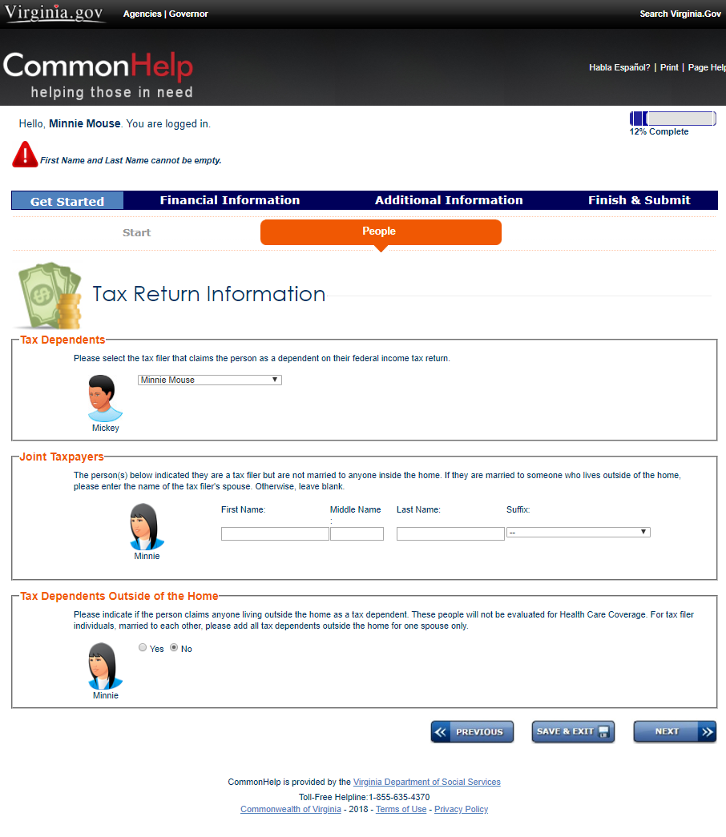
Answer the questions in the below screen for each person in the household. (Blindness/Disability, Current/Past Social Services Assistance, Pregnancy, MCO selection, and Medical Services (Retro coverage).

Select the answers for the questions below.

In this summary section, you may add additional people that were not originally reported to you.

Review the answers for these questions below in this summary section.

Review the answers for these questions below in this summary section.

EMPLOYMENT AND SELF EMPLOYMENT
Answer the question for employment or self/employment for all the household members.
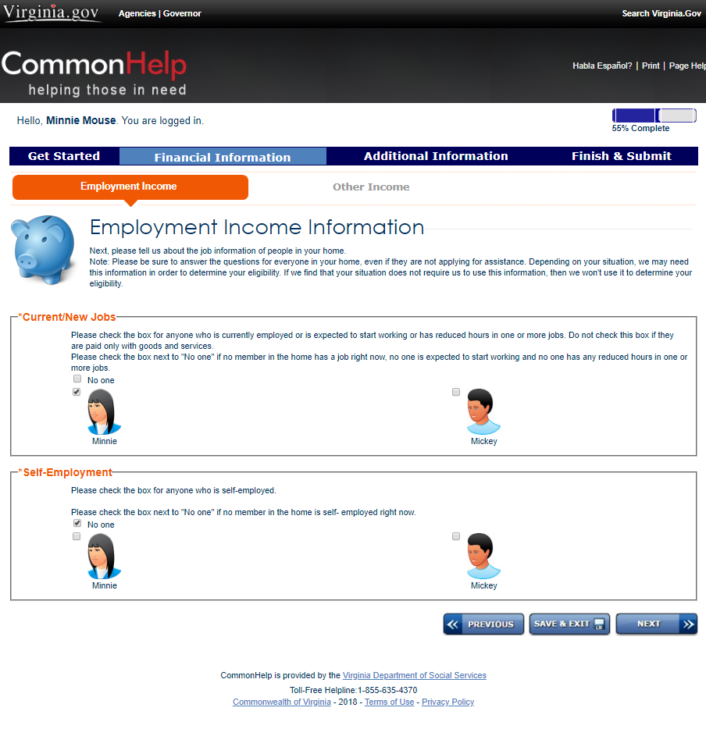

Enter the employment details on the below screen. (You will be presented a detail screen for each job entered.)

Enter Bonus or Commission Pay in the section below if it applies, if not choose NEXT.

MONEY FROM OTHER SOURCES
Answer the questions about Money from other sources for all the household members.
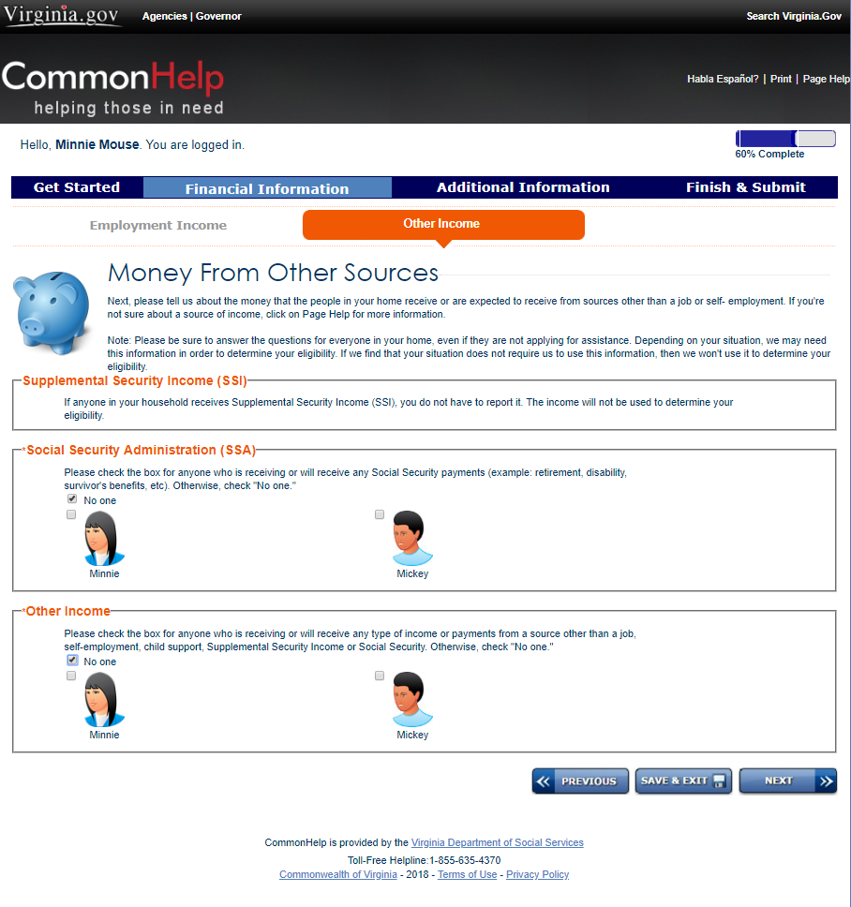

Yearly gross income screen shown below – This screen is used if the individual obtains income based on contract work. Choose NEXT if it does not apply.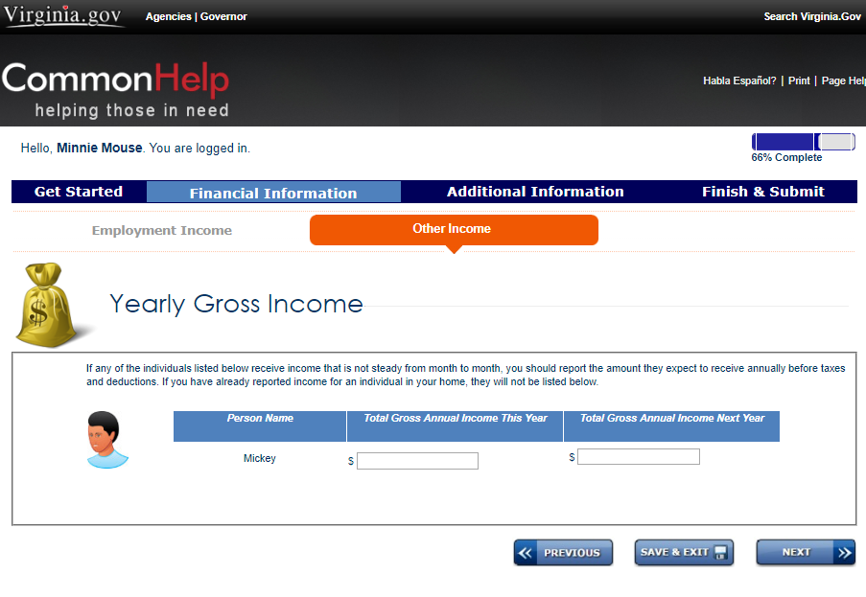

ADDITIONAL INFORMATION
Answer the additional questions for household members. (Foster Care/Department of Juvenile Justice, Other Health or Long-term care Insurance, Daily Living Assistance, Tribal/Indian Health Services)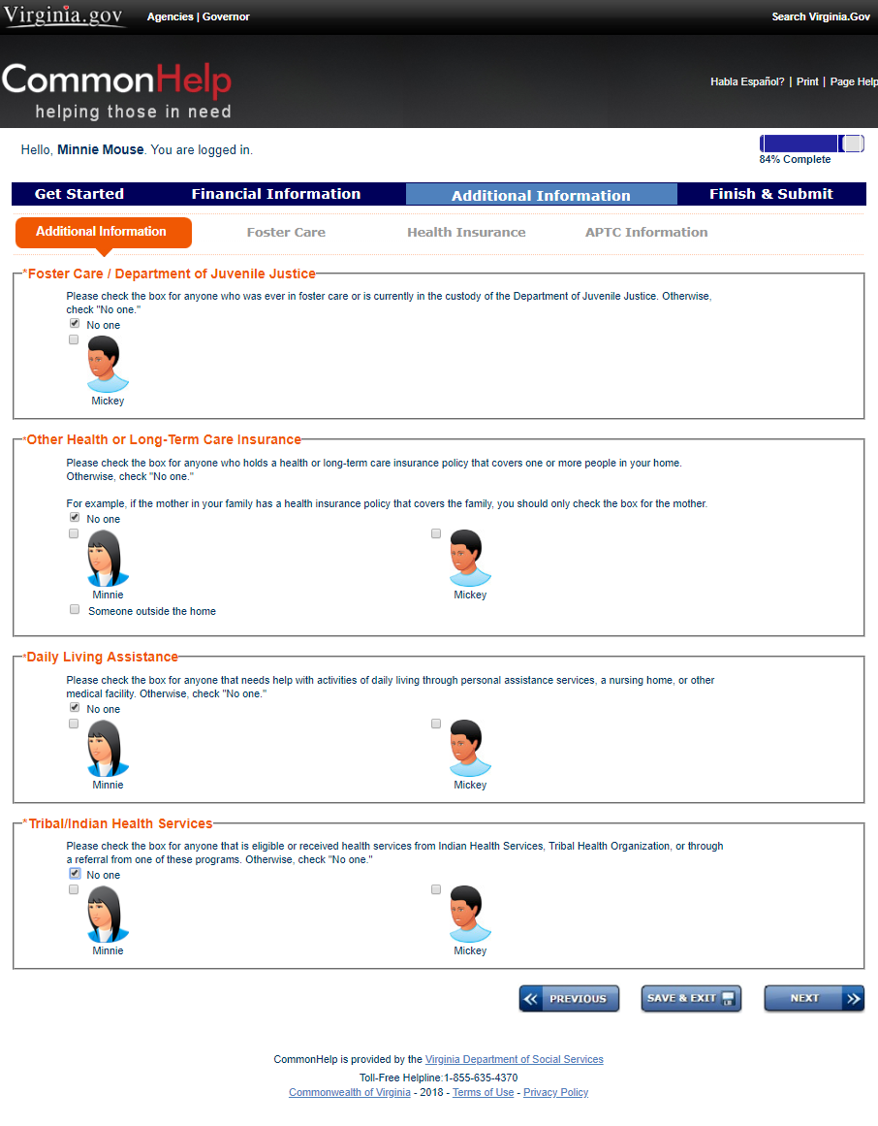

ATTACHING DOCUMENTS
Submit the applicant’s documents. In this section, you may upload the following file types: “.jpg”,”.pdf”,”.tif”,”.doc”,”.xls(x)”,”.txt”. You may attach up to 20 documents and each document must be 5MB or less.
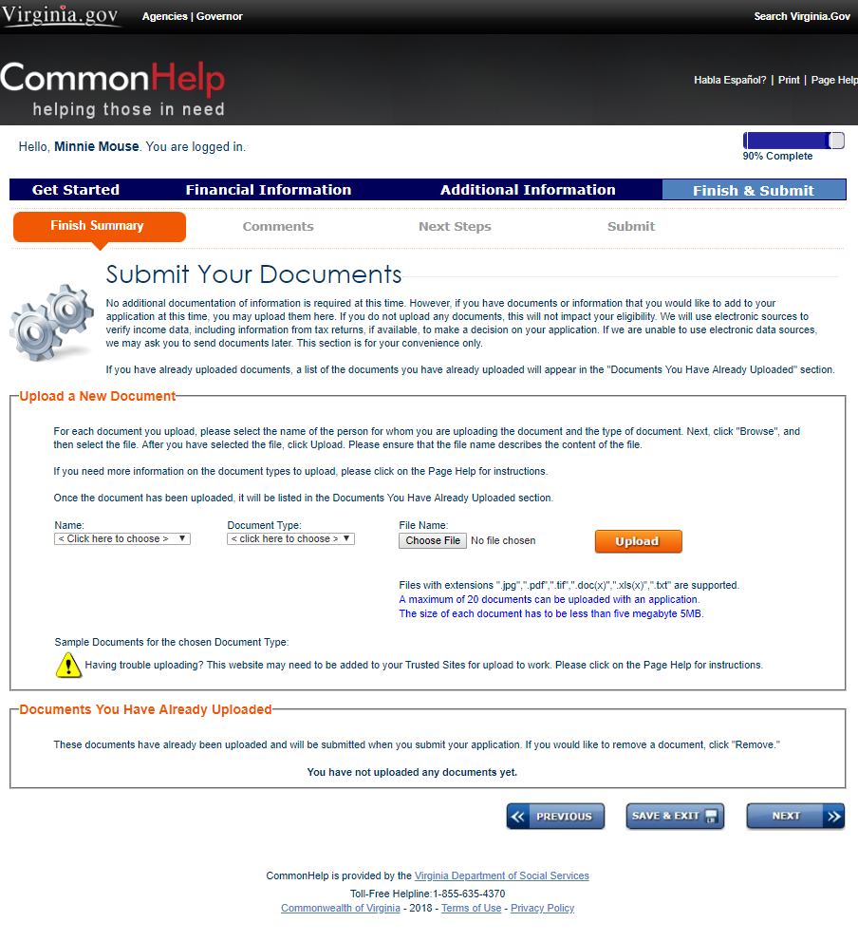

AUTHORIZED REPRESENTATIVE
Authorized Representative screen displays below. You would only fill out this screen if you have chosen this as “Who is submitting the application” and you have received written authorization from the applicant to authorize you to:
- Apply for benefits,
- Receive benefits,
- Receive requests for information needed to determine eligibility,
- Receive letters regarding actions take on the applicant’s case.

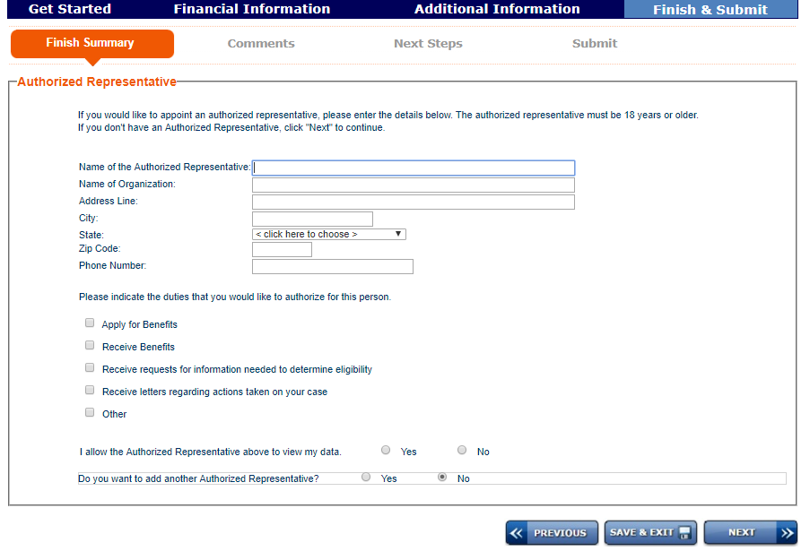
Note: Make sure to upload the written document from the applicant where you have been designated as an authorized representative.

CERTIFIED APPLICATION COUNSELOR/NAVIGATOR/BROKER
If you are a Certified Application Counselor/Navigator/Broker, you must complete the below screen.
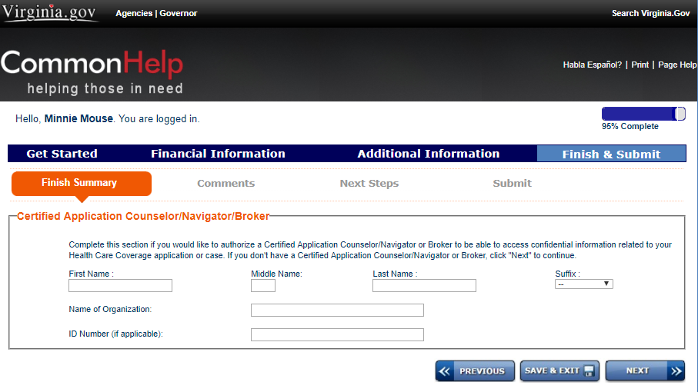
If you have any comments, you may enter them in the below text box.
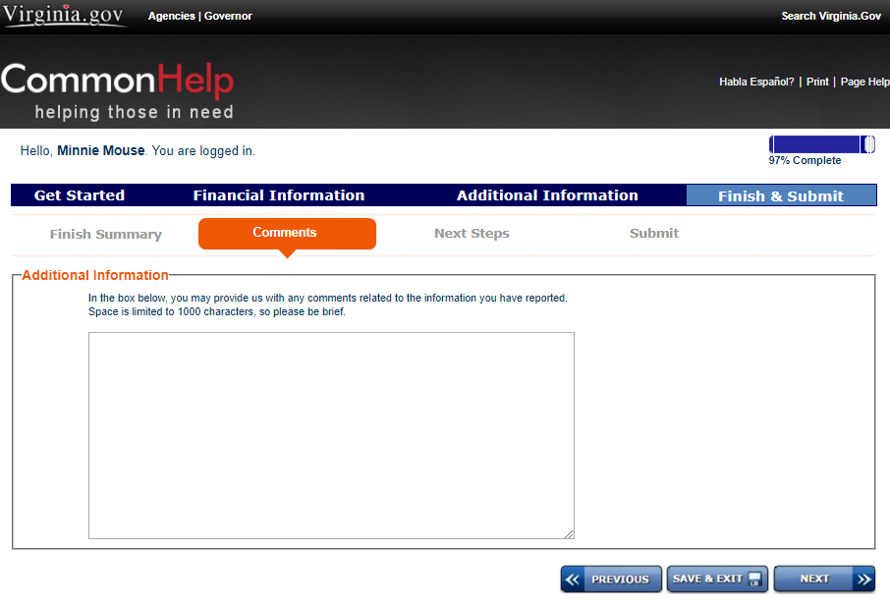
The below screen provides one last opportunity for the applicant to apply for more programs not originally selected or to continue with this health care application. We will choose “Complete my healthcare application.”
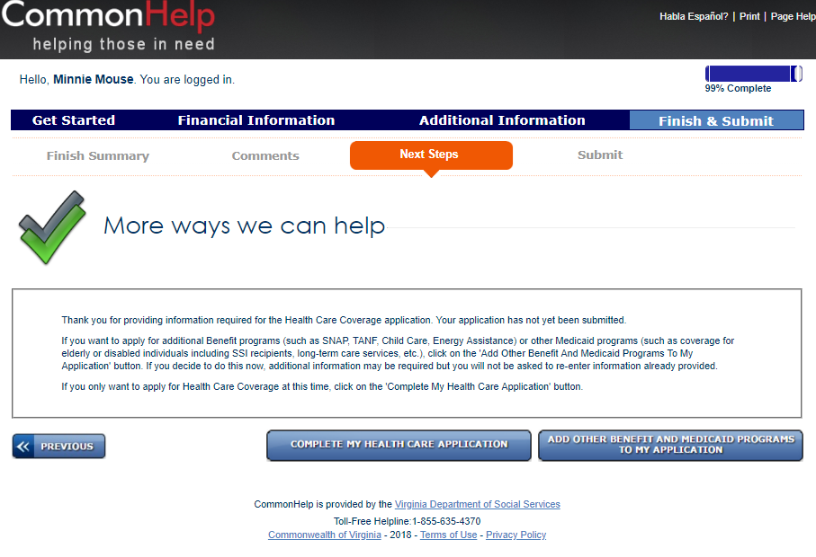

SIGNING YOUR APPLICATION
The below screen provides the applicants Responsibilities, Rights and Penalties, Consent to exchange information, Request to register to vote, Authorization to use Income Data to Renew Coverage, Signature Declaration and Electronic Signature section.
Read the Responsibilities, Rights and Penalties and select an option for consent.

Select an option for: request to vote, authorization to use income date, signature declaration. Enter the Legal Name for the account in the Electronic Signature section and type in the password for this account. Click Next.

The CommonHelp website may ask you to log in again and choose SUBMIT one more time. When the application has been successfully submitted, you will see a message providing you with the Application Tracking number. Example “TXXXXXXX”.
Once an application has been submitted, it is no longer available for updates or corrections. If updates or changes are needed, the individual will need to reach out to the appropriate local agency to submit corrections or changes to their application. Local agency information may be found using the following link:
http://dss.virginia.gov/localagency/index.cgi

ADDITIONAL RESOURCES
If the applicant has questions about their submitted application, you may refer them to the CommonHelp Call Center for assistance at 1-855-635-4370, Monday - Friday 8am – 7pm, Sat 9am-Noon. Individuals may also want to review the User Manuals found on the below website:
- User Manual – Case Association
- User Manual – Check My Benefits
- User Manual – Renew My Benefits
- User Manual – Report My Changes
http://dss.virginia.gov/community/commonhelp/

Local Agency - Temporary Process for AC 109 Incarcerated Individuals Applications

Notes:
CommonHelp will be updated at the end of March.

