This document will give information and instructions on how to Access, Read and Use:
- Client Management Report – Local – RP-077B
Release notes from 4/30/18 Broadcast VaCMS April Release
EAP Client Management Report (CR 280)
ISSUE: EAP Client Management State (EDSP EM RP.77A) and EAP Client Management Local Reports (EDSP EM RP.77B) for Crisis and Cooling did not display denial and/or closure reason code descriptions, therefore, statistical counts as of the report run date for the active components were not correct.
CHANGE: VACMS will now correctly display denial and/or closure reason codes descriptions for both reports. Additionally, statistical counts of approved, denied, closed or pending service request(s) for each component were corrected, as of the report run date for the active components.
REQUIRED WORKER ACTION: No worker action required.

Local agencies will use these reports to examine and track service requests/applications to aid in case processing and for informational purposes to assist with staffing needs, board of directors’ data, etc.
How to access Reports – In VaCMS, from the Left Navigation, go to the following:
Report Search / EAP / select RP077B
- The reports can be pulled up by the Report ID or the Report Name
- Both reports are generated in PDF format
- Fuel/Crisis will run between October 1 and May 1. Cooling will run June 14-September 30
---------------------------------------------------------------------------------------------------------------
Client Management Report – Local – RP-077B

Report Description:
This report provides counts of total cases processed for the active component(s). The report also provides counts of approved, denied, closed or pending service requests for Fuel, Crisis and Cooling Assistance applications. The report will display these counts as of the report run date for the active component(s). For all components, the report will break down the county by Denial and Closure reasons. The report also provides the details on the EAP Crisis/Cooling service requests and Fuel Assistance applications at the time of the report run.
Report Schedule Run:
Weekly report run every Sunday morning that will pick up cases that have approved, denied, closed or pending service request for the component. This report can be sorted by locality.

SCREENSHOTS
- Go to the Left Navigation in VaCMS
- Click on Reports Search / EAP / Select the report I.D. or Report Name and click Search.
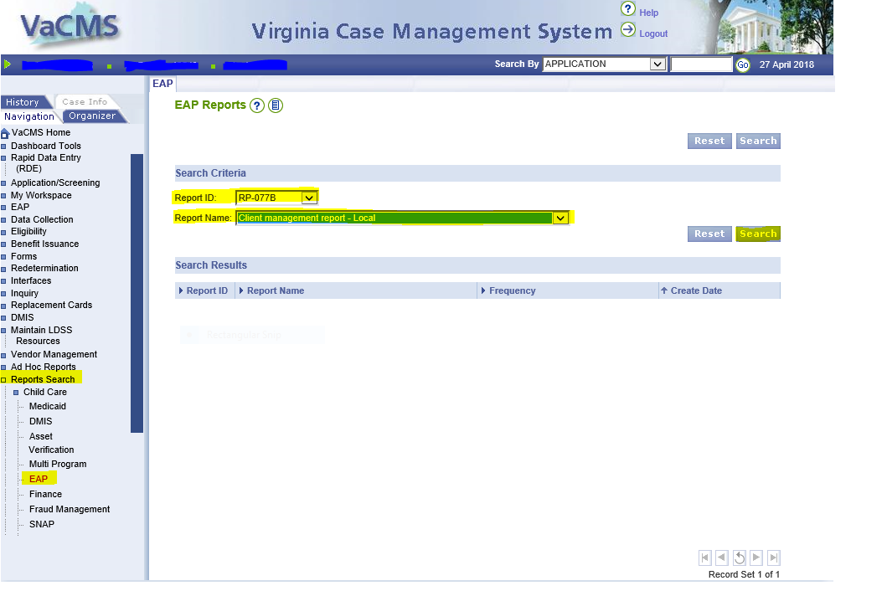

- The Report I.D. and Name will appear. Click the blue hyperlink.
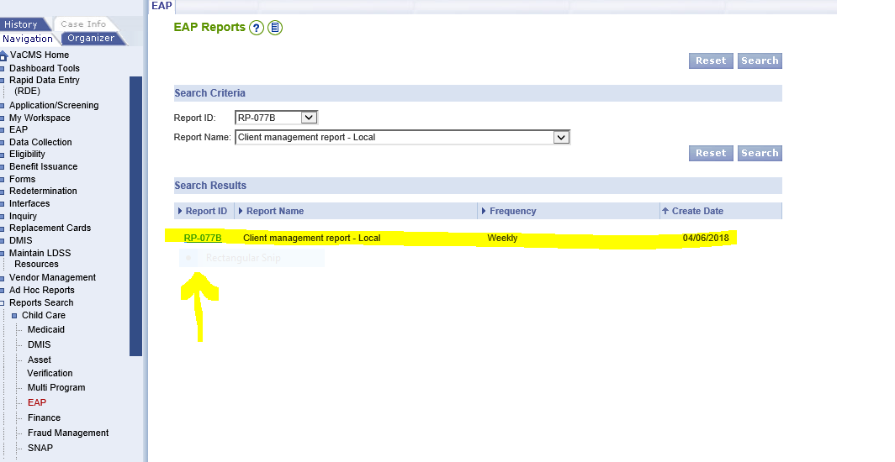

- Select your locality, then click the pdf icon next to the most recent report begin date.

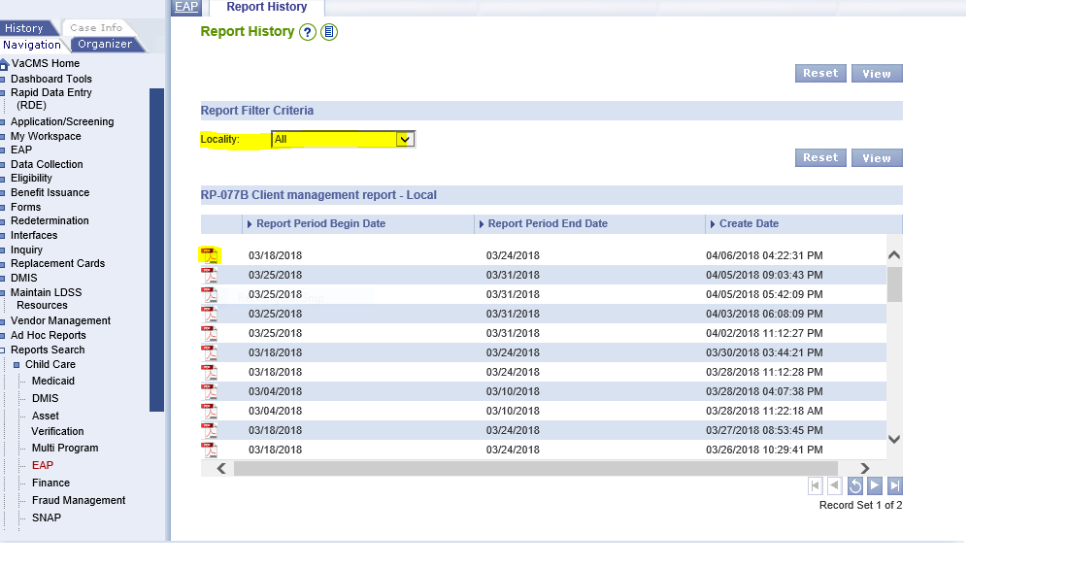
- The report will display. Use the Right scroll bar or the page up and down keys to navigate.
- This report may be saved or printed.
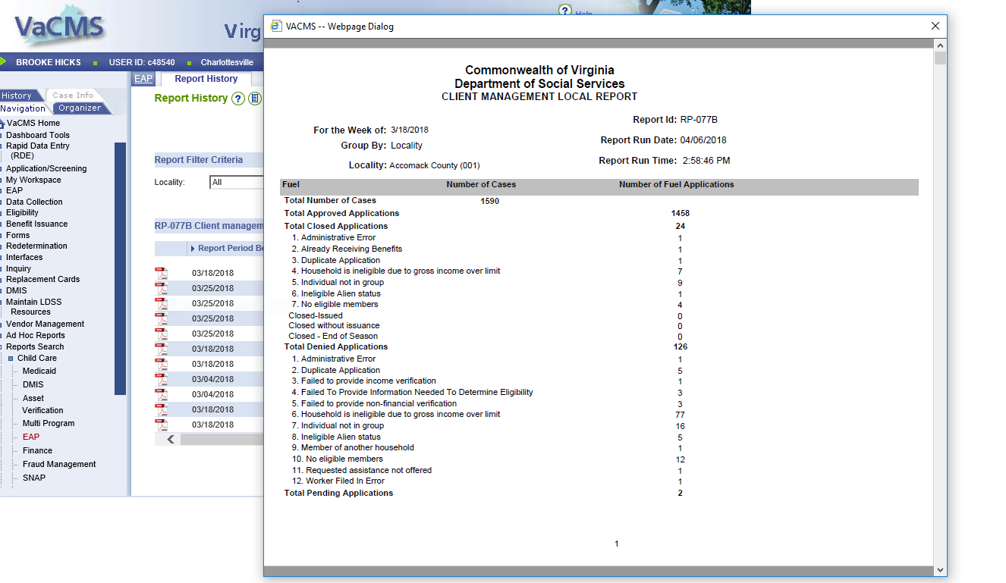

Field Description
Locality | Displays the locality of the case based on physical address.
EAP Component | Displays the EAP Component type i.e. Fuel, Crisis, and Cooling.
Details
Case Name | Displays the case name.
Case Number | Displays the case number.
Worker I.D. | Displays the worker I.D.
EAP App I.D. | Displays EAP service request or Fuel Assistance application I.D.
Fuel Type (for Fuel Component)  Service Request (For Cooling and Crisis) | Displays fuel type selected on the Fuel Application.  Displays service request type selected on Cooling/Crisis application.
Application Date | Displays the application date.
Disposition Date | Display the disposition date  - Will display Certification date for the Service Request (SR) or Fuel Assistance application I.D.  - Will display closure date for the SRs or Fuel Assistance with status as Closures  - Will display blank for pending SRs or Fuel Assistance applications.
Auth. Amt. (Authorized Amount) | Displays the authorized amount for Crisis/Cooling service requests or Fuel Assistance applications.  Fuel – Approved case will display the amount only after BD.  Crisis and Cooling – Will display the amount authorized for the service request.
Paid Amt. (Amount) | Total amount paid for the Crisis, Cooling service request and Fuel Assistance applications.
Status | Displays the status of the service request or Fuel Assistance application.
Denial/Closure Reason | Displays the Denial/Closure reason associated with the service request or Fuel Assistance application, along with the description.
Total Number of Cases | Computes and displays the cumulative count of VaCMS cases that have been approved, denied, closed or have pending service requests within the component as of the report run date. Reported under Number of Cases.
Total Approved Service Requests | Computes and displays the number of service requests approved within the active component as of the report run date. Service requests or Fuel Assistance applications closed after the approval are not counted as Approved. Reported under Number of Cases. For Fuel Under: Number of Applications.
Total Pending Service Requests | Computes and displays the number of service requests or Fuel Assistance applications that are pending within the active component as of the report run date. Reported under Number of Service Requests. For Fuel Under: Number of Applications.
Total Service Requests | Computes and displays cumulative total number of service requests across approved service requests or Fuel Assistance applications + Denied Service Requests or Fuel Assistance applications+ Closed Service Requests or Fuel Assistance applications + Pending Service Requests or Fuel Assistance applications for the active component. Reported under Number of Service Requests. For Fuel Under: Number of Applications.

Report Logic:
- This report displays a count of distinct cases that have service request or Fuel Assistance applications in approved, closed, denied or pending statuses as of the report run for the active components, only.
- The report will also display counts of approved, denied, closed and pending service requests or Fuel Assistance applications for the active component as of the report date.
- The report will display details for EAP service requests as mentioned on the details section of the report run date.
- A service request or Fuel Assistance application are categorized based on the latest status on it. Service requests or Fuel Assistance applications closed after approval are reported as closed.
- For Approved service requests or Fuel Assistance applications, pick records from EA_SERVICE_REQUEST where the STATUS_CD=AP (Approved).
- For Denied service requests or Fuel Assistance applications, pick records from EA_SERVICE_REQUEST where the STATUS_CD=DN (Denied).
- For Closed service requests or Fuel Assistance applications, pick records from EA_SERVICE_REQUEST where the STATUS_CD=TN (Closed).
- For Pending service requests or Fuel Assistance applications, pick records from EA_SERVICE_REQUEST where the STATUS_CD=PN (Pending).
- The report will display the following components:
- Crisis and Fuel when Crisis and Fuel are active components.
- Cooling when cooling is active component.
- A service request or Fuel Assistance application closed after issuance will be displayed under Total Closed Service Requests and are categorized as “Closed-Issued.”
- A service request or Fuel Assistance application that closed without issuance will be displayed under Total Closed Service Requests and are categorized as “Closed without issuance.”
- A service request or Fuel Assistance application closed as part of an end of season is displayed under Total Closed Service Requests and categorized as “Closed – End of Season.”
- After the end of each summary section, the report will include the following – for Cooling and Crisis
- “Only EAP applications associated/attached with VaCMS case(s) are included in this report. If an application has multiple service requests, each service request is counted separately.
- After the end of each summary section, the report will include the following for Fuel Assistance
- Only EAP applications associated/attached with VaCMS case(s) are included in this report. Multiple applications for the same case are included in the Total Applications count.
- There will be a page break after each summary section starting the details of the new component.
- There will be a page break after each details section to start the summary of the new component.
- The report will give breakdowns of counts for applications/service requests that have been denied/closed within the component for the denial/closure reason. These breakdowns are provided for the component based on the following date.
- Fuel and Cooling: Breakdowns will be provided from FFY 2018.
- Crisis: Breakdowns will be provided from FFY 2019.

