This document gives Information & Instructions on how to Access, Read and Use:
- Client Management Report – State – RP-077A
Release notes from Broadcast 4/30/18 titled VACMS April Release

EAP Client Management Report (CR 280)

ISSUE: EAP Client Management State (EDSP EM RP.77A) and EAP Client Management Local Reports (EDSP EM RP.77B) for Crisis and Cooling did not display denial and/or closure reason code descriptions, therefore, statistical counts as of the report run date for the active components were not correct.
CHANGE: VACMS will now correctly display denial and/or closure reason codes descriptions for both reports. Additionally, statistical counts of approved, denied, closed or pending service request(s) for each component were corrected, as of the report run date for the active components.
REQUIRED WORKER ACTION: No worker action required.

How to access Reports – In VaCMS, from the Left Navigation, go to the following:
Report Search / EAP / select RP077A
- The reports can be pulled up by the Report ID or the Report Name
- Both reports are generated in PDF format
- Fuel/Crisis will run between October 1 and May 1. Cooling will run June 14 - September 30

---------------------------------------------------------------------------------------------------------------
Client Management Report – State – RP-077A

Report Description:
This report provides counts of total cases processed for the active component(s). The report also provides counts of approved, denied, closed or pending service requests for Fuel, Crisis and Cooling Assistance applications. The report will display these counts as of the report run date for the active component(s). The report will break down by Denial and Closure reasons for all EAP Components.
Report Schedule Run:
Weekly report run every Sunday morning that will pick up cases that have approved, denied, closed or pending service request for the component. This report can be sorted by locality.

SCREENSHOTS
- Go to the Left Navigation in VaCMS
- Click on Reports Search / EAP / Select the report I.D. or Report Name and click Search.

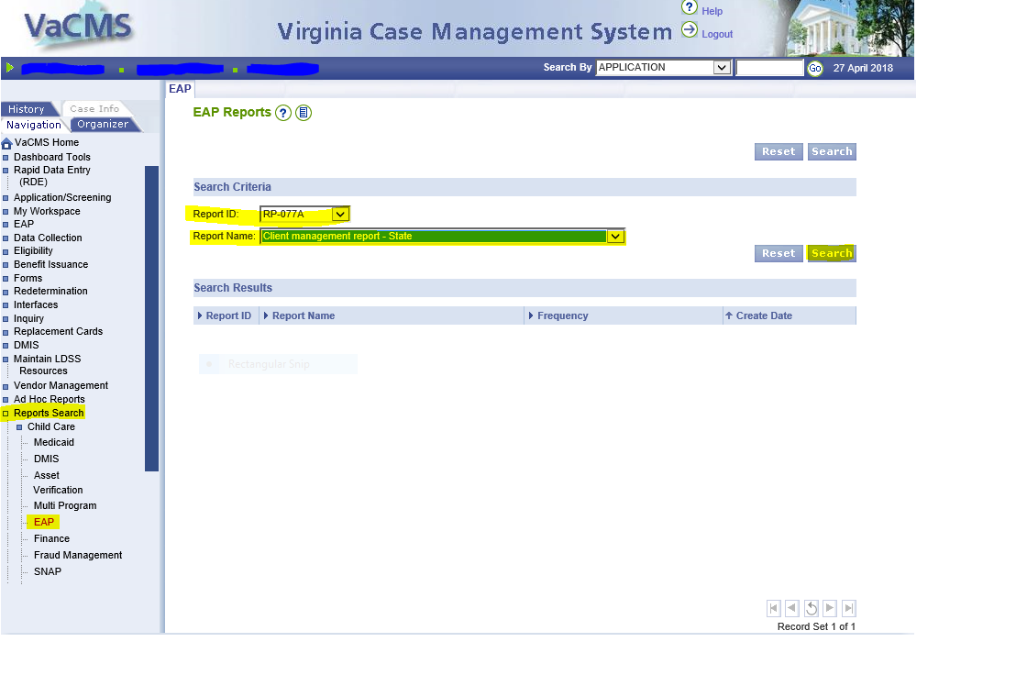

- The Report I.D. and name will appear. Click the blue report I.D. hyperlink.
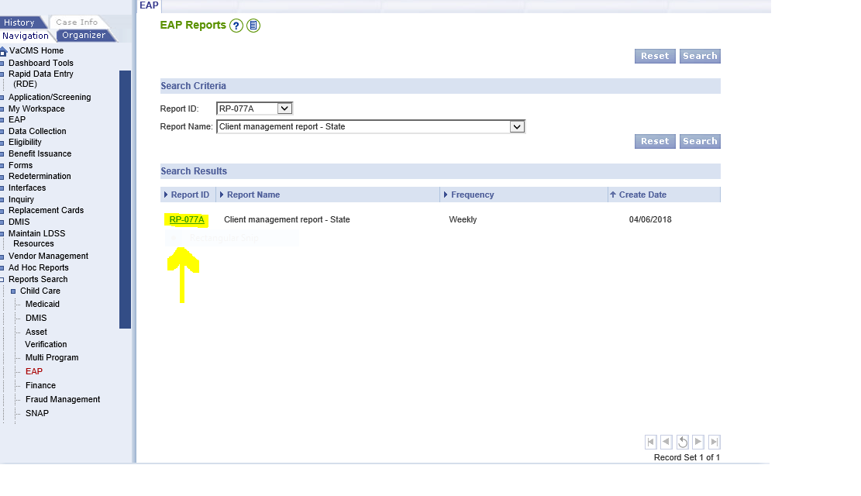

- Click on the most recent report date’s PDF icon

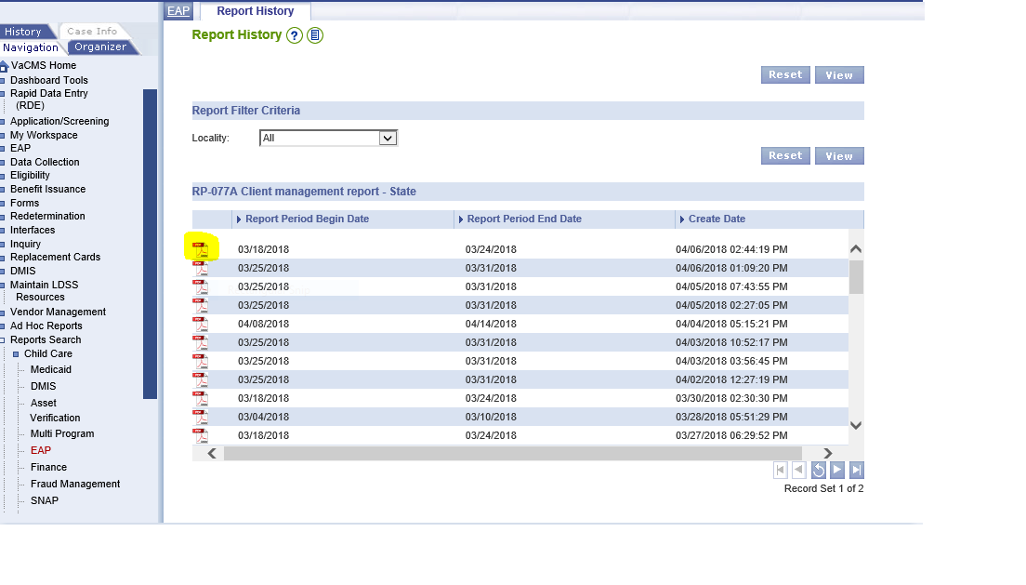
- The report will display. Use the page up and down keys or the scroll bar on the right hand side to navigate through the report. You may save or print the report, as needed.
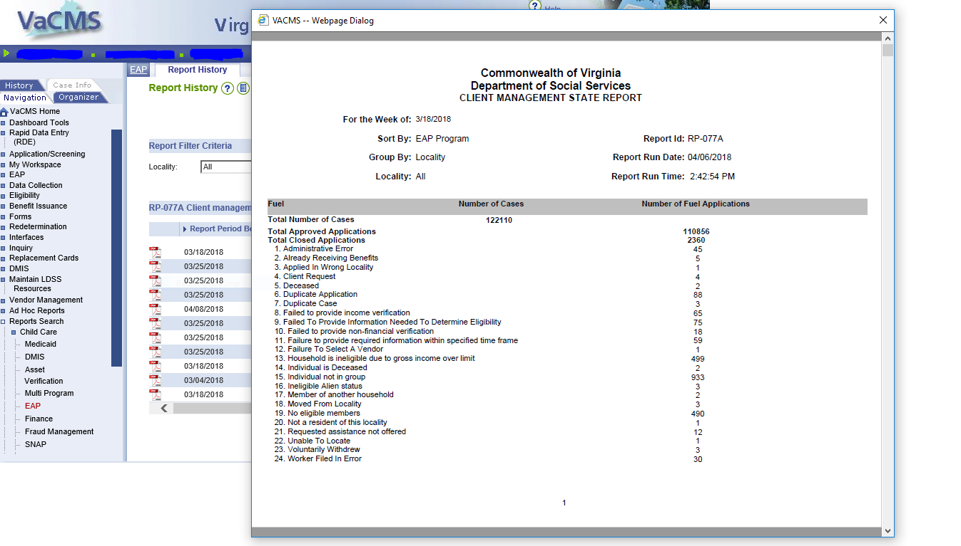
Field Description
Locality | Displays the locality of the case based on physical address. *This field will be blank for the Statewide summary page.
EAP Component | Displays the EAP Component type i.e. Fuel, Crisis, and Cooling.
Total Number of Cases | Computes and displays the cumulative count of VaCMS cases approved, denied, closed or have a pending service requests within the component as of the report run date. Reported under Number of Cases.
Total Approved Service Requests | Computes and displays the number of service requests approved within the active component as of the report run date. Service request (EAP Applications) closed after approval are not counted as Approved. Reported under Number of Service Requests. For Fuel – under Number of Applications.
Total Closed Service Requests | Computes and displays the number of service requests closed within the active component as of the report run date. Service request (EAP Applications) closed after approval will be counted as closed. Reported under Number of Service Requests. For Fuel under – Number of Applications.
Total Pending Service Requests | Computes and displays the number of service requests that are pending within the active component as the report run date. Service request (EAP Applications) closed after approval are counted as closed. Reported under Number of Service Requests. For Fuel under – Number of Applications.
Total Denied Service Requests | Computes and displays the number of service requests denied within the active component as of the report run date. Service request (EAP Applications) closed after approval are counted as closed. Reported under Number of Service Requests. For Fuel under – Number of Applications.
Total Service Requests | Computes and displays total number of service requests across approved service requests (EAP Applications) + Denied Service Requests (EAP Applications) + Closed Service Requests (EAP Applications) + Pending Service Requests (EAP Applications) for the active component. Reported under Number of Service Requests. For Fuel under: Number of Applications.

Report Rules:
- This report displays a count of distinct cases that have service requests or Fuel assistance application in approved, closed, denied or in pending status as of the report date for the active components only.
- The report will also display counts of approved, denied, closed and pending service requests or Fuel Assistance application for the active component as of the report run date.
- A service request or Fuel Assistance application is categorized based on the latest status on it. Service requests closed after approval are reported as closed.
- For Approved service requests or Fuel Assistance application, pick records from EA_SERVICE_REQUEST where the STATUS_CD=AP (approved).
- For Approved service requests or Fuel Assistance application, pick records from EA_SERVICE_REQUEST where the STATUS_CD=DN (Denied).
- For Approved service requests or Fuel Assistance application, pick records from EA_SERVICE_REQUEST where the STATUS_CD=TN (Closed).
- For Approved service requests or Fuel Assistance application, pick records from EA_SERVICE_REQUEST where the STATUS_CD=PE (Pending).
- The report will display the following components:
- Crisis and Fuel when Crisis and Fuel are active component
- Cooling when cooling is active component
- A service request or Fuel Assistance application that closed after issuance are displayed under Total Closed Service Requests and will be categorized as “Closed-Issued”.
- A service request or Fuel Assistance application that closed without issuance are displayed under Total Closed Service Requests and will be categorized as “Closed without issuance”.
- A service request or Fuel Assistance application closed as part of end-of-season will are displayed under Total Closed Service Requests and are categorized as “Closed-End of Season”.
- After the end of the summary section, the report will include the following for Cooling and Crisis:
- “Only EAP applications associated/attached with VaCMS case(s) are included in this report. If an application has multiple service requests, each services request is counted separately.
13) After the end of the Fuel summary section, the report will include the following:
a. “Only EAP applications associated/attached with VaCMS cases(s) are included in this report. Multiple applications for the same case are included in the Total Applications count.”
14) There will be a page break after each summary section starting details of a new component.
15) The report will give a breakdown of count and applications/service requests that have been denied/closed within the component for the denial/closure reason. These breakdowns provided for the component are based on the following dates:
- Fuel and Cooling: Breakdowns provided from FFY 2018.
- Crisis: Breakdowns provided from FFY 2019.

