General Notes
The Medicaid Covered Group page should be completed for the LIFC parent/caretaker(s) in the home, not the children. Children should follow the information as entered for the parent/caretaker(s) and FAMIS Plus children should be evaluated for Extended Medicaid before FAMIS.
The Medical Earnings Status page is used to track the ongoing eligibility of an individual in Extended Medicaid. The page contains the information the automated run checks against, the follow-up codes and dates on the Medical Earnings Status page determine if an individual is eligible for Extended Medicaid in future months or if an Extended Medicaid Earnings report should be mailed.
All Extended Medicaid actions take place in VaCMS. DMAS no longer uses the follow up date and codes in MMIS to send reports or terminate coverage. While VaCMS does send some date and code information over to MMIS, workers should note that this information does not affect an individual’s eligibility in Extended Medicaid or their ongoing eligibility once Extended Medicaid ends.
The Medicaid Covered Group Page
The Medicaid Covered Group page is the page in VaCMS that is used to indicate whether or not someone is eligible for Extended Medicaid.
Using this Page When an Individual Is Not Eligible for Extended Medicaid
Even if an individual is not eligible for Extended Medicaid, the worker will need to complete this screen for each LIFC recipient that is being evaluated for Extended Medicaid but is not eligible for this program.
In the dates section, the worker should enter the effective begin date that matches the first day of the first month in which the individual is not eligible for Extended Medicaid. The end date should match the next renewal date for that individual. This ensures that if subsequent changes are made to the case during the certification period that the individual will not be evaluated for Extended Medicaid. The dates are able to be changed in the future should the individual become eligible for Extended Medicaid.
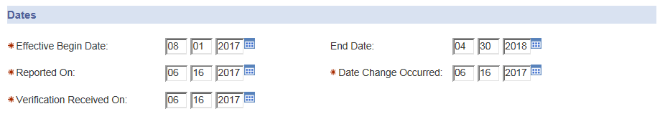
Please note that if there is a prior screen already completed, the worker will need to enter an effective date that is the day after the end date on the prior screen. The worker will enter the information over the old information to create a historical record as they cannot select the Add Medicaid Covered Group button on the summary page when a screen already exists for that individual. They can only select that button if they are completing the screen for a new individual. The following error message is received when a worker tries to enter a new Medicaid Covered Group screen for an individual with an existing screen:
In the Other Medicaid Covered Groups section, the individual’s Medicaid Covered Group should be LIFC, the Status should be Terminated, and the Agreement/Status Date should match the effective begin date. If the Effective Begin Date is in the future, the agreement status date can be the current date.
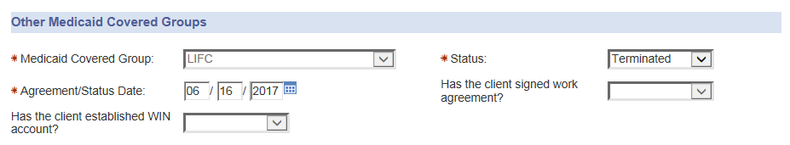
In the Extended Medicaid Section, the question “Has the client or Parent/Caretaker correctly received LIFC three of the last six months?” must be answered “NO” for the individual to be evaluated for covered groups other than Extended Medicaid. The worker does not have to answer any more questions on the page after this point.
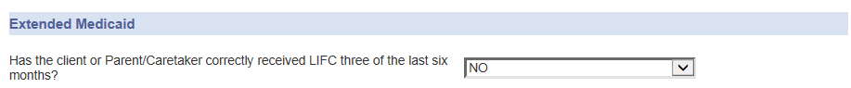
When the worker runs eligibility and certifies the case, please be sure to carefully review the notice. If any information is incorrect the worker should suppress the notice, generate/send a manual notice, and upload the manual notice to DMIS.
Using this Page If an Individual Is Eligible for Extended Medicaid in a Past Month for 12 Month Extended Medicaid
The page should be completed using the correct information if Extended Medicaid is being evaluated for a month in the past. The information populated to the Extended Medical Earning Status page is based on Extended Medicaid being established as of the current date of action as well as the renewal date, but the information should be updated to align the dates. The worker will need to complete this screen for each LIFC recipient that is being evaluated for Extended Medicaid.
In the dates section, the worker should enter the effective begin date that matches the first day of the first month in which the individual was eligible for Extended Medicaid. The end date should match the renewal date for that individual based on their Extended Medicaid Eligibility as their new renewal date may not be the same as the current renewal date. This ensures that if subsequent changes are made to the case during the certification period that the individual will continue be evaluated for Extended Medicaid. The dates are able to be updated in the future should the individual become ineligible for Extended Medicaid.
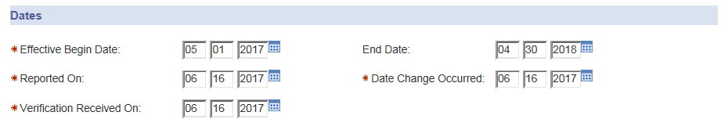
NOTE: If there is a prior screen already completed, the worker will need to enter an effective date that is the day after the end date on the prior screen. Depending on the information on the prior page, you will take one of two courses of action. If the prior screen showed the individual as ineligible, extend the end date on the prior screen to the day before they became eligible for Extended Medicaid. Then save and go back and enter the new information. If the prior screen showed the individual as eligible, be sure the end date on the prior screen was the last day of the last month in which they were eligible for extended, then complete new information for the time period where they were not eligible. Use the criteria in the previous section however the end date should be the last day of the last month in which they were ineligible. Save and go back and enter the new information. In both cases you will have a current screen with historical records, but the number of historical records will vary.
In the Other Medicaid Covered Groups section, the individual’s Medicaid Covered Group should be LIFC, the Status should be Terminated, and the Agreement/Status Date should match the effective begin date.
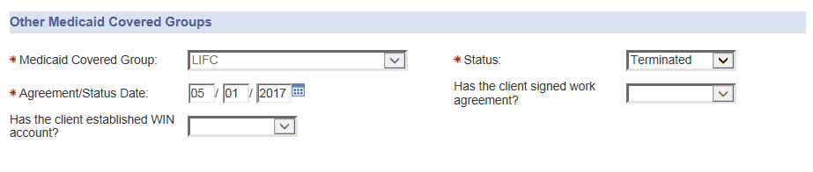
In the Extended Medicaid Section, the question “Has the client or Parent/Caretaker correctly received LIFC three of the last six months?” will be answered “YES” and the LIFC failure reason will be “Excess Earnings.” The question “In what month Extended MA should have begun?” should match the same month as the effective begin date, and depending on the number on months in the past the Extended Medicaid should have begun, the worker will answer the follow up code questions appropriately. It is possible that the worker will need to send the earnings reports manually to the customer to complete before they are able to authorize the Extended Medicaid coverage.
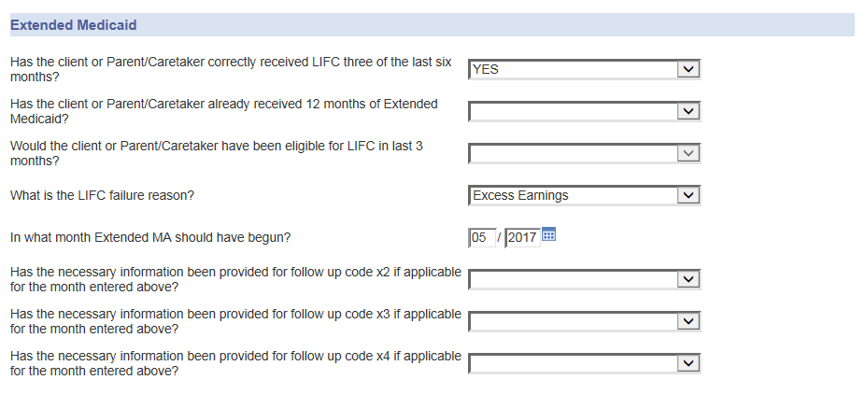
If the information does not save after entering those responses the worker may have to go back and re-enter the information and re-save. If the information does not save after a few attempts, please document the case to reflect the correct information. The month Extended Medicaid should have begun will not populate over to the Extended Medical Earning Status page as the follow-up date and the worker will need to update that information manually.
RCR should be run beginning the first month in which the individual was eligible for Extended Medicaid to preserve the change was processed correctly. The RCR result should show Extended MA “No Action Needed” as MMIS will not accept changes to move someone from one full coverage group to another full covered group. When the worker runs eligibility and certifies the case, please be sure to carefully review the notice of Extended Medicaid and the Earnings Report. If any information is incorrect the worker should suppress the notice, generate/send a manual notice, and upload the manual notice to VaCMS.

