BPRO, POSSESS, VASWP
Fall 2015 CONFERENCE
September 30-October 2
Norfolk Sheraton Waterside
777 Waterside Drive, Norfolk

www.visitnorfolktoday.com
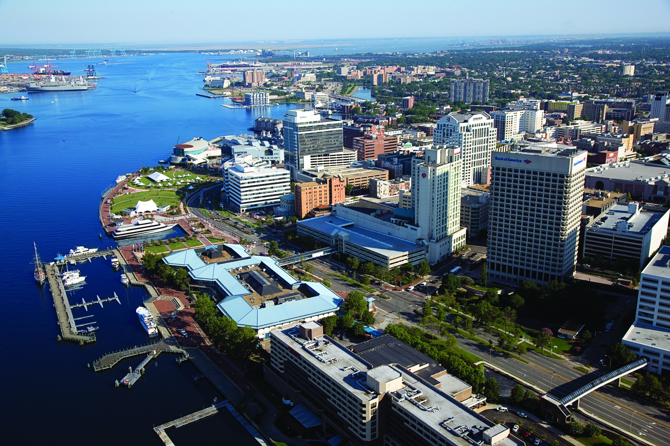

Conference at a Glance:

Wednesday, September 30, 2015
8:00 am Registration Begins
9:00 am-12:00 Pre-conference workshops (check time schedule for workshops)
12:15 -1:30 pm Lunch provided
1:30-3:00 pm Welcome
Keynote Speaker
2:00-3:00 pm Migration Lab
3:00-3:15 pm Break on your own
3:15 -4:45 pm Workshops
BPRO Business Meeting
POSSESS Business Meeting
5:00 pm Dinner on your own
Enjoy Norfolk

Thursday, October 1, 2015

7:00 am Breakfast provided
8:00-9:00 VASWP General Board Meeting
9:00-10:30 am VASWP Business Meeting
Workshops
10:30-10:45 am Break on your own
10:45 am-12:15 pm Workshops 12:15-1:45 pm Lunch provided www.visitnorfolktoday.com
1:45-3:15 pm Workshops
3:15 -3:30 pm Break on your own
3:30 -5 pm Workshops
5:00 pm Dinner on your own
Enjoy Norfolk
BPRO Business meeting
Friday, October 2, 2015

7:00 am Breakfast provided
9:00-10:30 am Workshops
Benefit Panel/ Migration
10:30-10:45 am Break on your own
10:45-12:00 Benefit Panel continued/ Migration continued
Workshops
*************************************************************************************************************

BPRO/POSSESS/VASWP Hospitality Suite is located on the 10th Floor, Presidential Room. Come network with LDSS, DSS employees in an informal setting. Remember Conference ID is required for Hospitality Suite. Due to ABC laws, alcoholic beverages cannot be removed from the Hospitality Suite. Only those 21yrs and over allowed to consume alcoholic beverages. Beer, Wine, Soda and water will be served. Please remember to enjoy in moderation and drink responsibly.
Hours of operation: Tuesday: 9-11 pm; Wednesday: 8-11 pm; Thursday: 8-10pm

Words of Welcome:
BPRO:

Welcome to Norfolk for our 2015 Fall Conference “Let’s Do It Again”. Norfolk has seven miles of Chesapeake Bay beachfront and a total of 144 miles of shoreline along their lakes, rivers, and the Bay. Norfolk is home to the world’s largest naval base and the North American Headquarters for NATO (North Atlantic Treaty Organization). Today Norfolk is the major naval and shipping hub, as well as the center of the Hampton Roads region.

“Let’s Do It Again” is to refresh and build on our policy knowledge and network with our BPRO, VASWP, and POSSESS members, as well as our State colleagues. We have started migration Phase I with the Virginia Case Management System to implement DMIS, central printing, and ABD/LTC Medicaid application determinations. This is a new and exciting challenge for us and with it we will continue to grow thru these changes. It is important that we have a strong policy knowledge of all the benefit programs as we determine eligibility for our customers. Therefore, our Professional Development committee has planned for this conference to refresh our policy knowledge in TANF, SNAP, and Medicaid. As we continue over the next couple of years implementing our Virginia Case Management System, it is important to continue to have great policy knowledge to ensure we are issuing correct benefits to the individuals and families we serve in our own communities.

October is Breast Awareness month; we are asking that you wear pink on Wednesday, October 1st for our pink out day in celebration of those fighting this tremendous battle today, and in remembrance of those who have fought the battle with dignity and honor. Besides skin cancer, breast cancer is the most commonly diagnosed cancer among American woman. About one in eight women in the US will develop invasive breast cancer during their lifetime.

I hope that you will gain in your policy knowledge while here at the conference and that you will meet some new colleagues that you can reach out to when you return to your agency. Please take some time while in Norfolk to enjoy the sites and wonderful restaurants that this city has to offer.

Carolyn Harlow
BPRO President
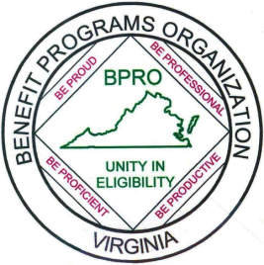
Don't ask what the world needs. Ask what makes you come alive and go do it. Because what the world needs is more people who have come alive." Howard Thurman

Words of Welcome (continued)

POSSESS:

Welcome back to the Sheraton Waterside Hotel in Norfolk, Virginia for our 2015 Fall Conference with BPRO and VASWP!

As you know, the theme for this conference is “Let’s Do It Again” and that is exactly what we are doing. We’re back here in the great city of Norfolk, Virginia. I know everyone had a wonderful time while here in May and I feel confident that this conference will be just as successful.

It’s really nice to have these joint conferences as it not only allows us the ability to network with fellow colleagues but it also gives us opportunities to attend workshops for training. All of this makes it possible for us to take back to our respective agencies new ideas, more knowledge and more energy, which will help expand our ability to grow and excel in our jobs.

As the POSSESS President, I want to thank each of you for your support and all the hard work you do each day for our agencies, families, adults and children. We are all important and each of us brings something special to the table.

I hope you will enjoy your stay here at the Sheraton Waterside and that you will have the opportunity to get out after the workshops are over to enjoy what Norfolk has to offer.

Please take a moment during the next few days to thank our conference planners for a job well done. The planners work really hard and without them there would be no conferences.

Inspirational Quote: “What you do today can improve all your tomorrows.” Ralph Marston
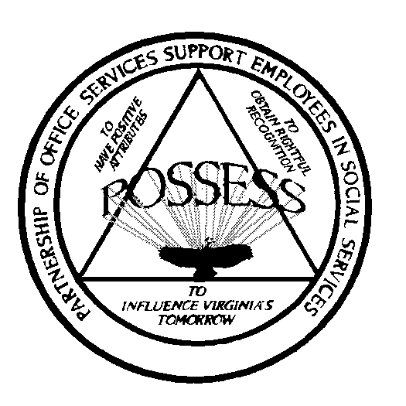
Jewell Wolfe, POSSESS President

Words of Welcome (continued)

VASWP:

LET’S DO IT AGAIN in the City of Norfolk, the great Eastern Region for the BRPO, POSSESS & VASWP 2015 Joint Conference.

During this conference you will be offered the opportunity to attend workshops that will help you render a more skillful service. As a member of VASWP we wish to help promote the growth and development in your area of expertise by way of the conferences and committee involvement. You are encouraged to network and fellowship with the other conference attendees.

As your VASWP President, I am looking forward to personally meeting each of you. Our goal is to have a successful fall conference. Enjoy your stay in Norfolk and take in a deep breath of the fall air in Eastern Virginia.

“Keep your thoughts positive because your thoughts become your words. Keep your words positive because your words become your behaviors. Keep your behaviors positive because your behaviors become your habits. Keep your habits positive because your habits become your values. Keep your values positive because your values become your destiny.” —Gandhi

Tonya Cunningham
VASWP President

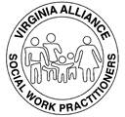

Our Conference Menus:

All meals will be served in the Ballroom

Wednesday, September 30th Lunch

Lunch, Welcome by Commissioner, and Keynote Speaker
Chicken Caesar Wrap
Grilled Chicken with Romaine Lettuce & Classic Caesar Dressing
Pasta Salad
Chef’s Choice of Desserts
Freshly Brewed Regular & Decaffeinated Coffee
Hot Herbal Teas & Iced Tea

Thursday, October 1st Breakfast
White and Wheat Bread, Fresh Fruit Bowl
Scrambled Eggs, Bacon and Breakfast Potatoes
Fresh Squeezed Orange Juice,
Fresh Brewed Starbucks Coffee & Assorted Herbal Teas

Thursday, October 1st Buffet Lunch
Caesar Salad
Warm Garlic Bread
Penne & Spaghetti with Marinara & Alfredo Sauces
Italian Meatballs
Chef’s Choice of Desserts
Freshly Brewed Regular & Decaffeinated Coffee
Hot Herbal Teas & Iced Tea

Friday, October 2nd Breakfast

Fresh Orange Juice
Assortment of Freshly Baked Breakfast Pastries & Muffins
Whole Fresh Fruit

Fruit Preserves and Sweet Butter
Freshly Brewed Regular and Decaffeinated Coffee
Hot Herbal Teas

PLEASE NOTE: BREAKS ARE ON YOUR OWN
Wednesday September 30, 2015

8:00 - 5:00 Registration

Pre-Conference Workshops

9:00 - 12:00 It’s time for Migration – Lab – Hands-on access to Migration
(Riverview) functionality in the training environment (B)

Facilitators: Bruce Blizard, Nancy Branch, Sandra Davis, Sheryl Carter-Thompson, Christopher Coley, Kevin Platea and Deborah Vaughn
We will have 8 laptops with the Training environment set up in a conference room (9 am – 12 pm and 2 pm -3 pm). This is open to anyone to sign-up and come to this session. A specific test application scenario is projected or placed on display with the expected outcome so that the participants can view the scenario they are to build. They may, however, try to build something else.
**You must sign up at the BPRO registration desk to attend this session**

9:00 - 10:15 Retirement Income Planning (B)
(Brandon)
Presenters: Elnetta Burke

Presented by the MEMBERS Financial Services Representatives located at Virginia Credit Union. Learn about your options so you can make informed decisions when it’s time to retire or change jobs.

10:30 - 12:00 Data Warehouse for Supervisors (B)
(Poplar Hall)
Presenters: Art Ritter

The workshop will provide live demos of the data warehouse demonstrating how to find reports and manipulate data to produce the results and order you want, and how to extract data for combining with other data and reporting. The focus will be on data and reports most commonly used and requested by supervisors, such as the MMIS Case Eligibility Review Report.
Wednesday September 30, 2015 (cont)

10:30 - 12:00 “I’ll Be Watching You”: Domestic Violence (V)
(Brandon)
Presenter: Patricia Jones-Turner

This workshop will discuss Transcending Self-Disclosure in Victimization: Discovering Hidden Truths Which Lead to Healing.

10:30 - 12:00 Manage Your Stress or Your Stress Will Manage You! (P)
(Merrimac)
Presenter: Denise Avent

Are you feeling stressed? Have you been down so long you don’t think about trying to get up? Are you working in a contagious stressful environment? This workshop has been designed to identify your stressors and develop strategies to manage stress.

(This workshop will be repeated at 9:00 on Thursday.)

10:30 - 12:00 What’s New in Excel 2010 (P)
(Monticello)
Presenter: Steve McCauley & Joyce Allen

This Excel 2010 Workshop will show you the new and improved features in Microsoft Excel 2010. We will demonstrate how to create and use Pivot Tables, Sparklines, Slicers, Conditional Formatting and more!

12:15 - 3:00 Lunch provided, served in Ballroom
Welcome:
Donna Allen, VP of Sales and Marketing, Norfolk Tourism
Carolyn Harlow, President BPRO
Jewell Wolfe, President POSSESS
Tonya Cunningham, President VASWP
Margaret Schultz, Commissioner, Department of Social Services

Keynote Speaker: Donna Hilfiger

“Let’s Do It Again… With Intention This Time”

Wednesday September 30, 2015 (cont)

2:00 - 3:00 It’s time for Migration – Lab – Hands-on access to Migration
(Riverview) functionality in the training environment (B)
**You must sign up at the BPRO registration desk to attend this session**

3:00 - 3:15 Break on your own

3:15 - 4:45 BPRO Business Meeting
(Poplar Hall) All BPRO members required to attend

3:15 - 4:45 POSSESS Business Meeting
(Merrimac) All POSSESS members required to attend

3:30 - 5:00 I Think a Child is Being Abused/Neglected-What Do I Do?
(Brandon)
Presenter: Gail Heath-Davidson

As professionals you are mandated to report suspected abuse and neglect to either your local social services or the State Department. This workshop will explain the ins and outs of what happens when making a report and the Code requirements for Child Protective Services intervention.

3:30 - 5:00 “Will I See You in September?”
(Monticello)
Presenter: Joy Patton

Whether you’re a seasoned VIEW worker or someone just starting out, this VIEW Refresher Training could be for you! It will be an overview of TANF Chapter 1000, including changes that occurred in TANF Transmittals 55 and 56, and important information from Chapter 900. Other topics include ESPAS data entry, required documentation and verifications, the work participation rate, and reports. Hope to see you there!!!

4:45 Enjoy Norfolk on your own

Thursday, October 1, 2015

7:00 - 9:00 Breakfast served in Ballroom
Come in and enjoy a simple breakfast to get you started.
(See menu on page 6)

8:00 - 9:00 VASWP General Board immediately followed by:

9:00-10:30 VASWP Business Meeting
(Montpelier) All VASWP Members are required to attend

9:00 - Noon It’s time for Migration – Lab – Hands-on access to Migration
(Riverview) functionality in the training environment (B)

Facilitators: Brue Blizard, Nancy Branch, Sandra Davis, Sheryl Carter-Thompson, Christopher Coley, Kevin Platea and Deborah Vaughn
8 laptops will be set up with the live VACMS Training Environment. Here you will be able to see the flow of ABD, Long Term Care and other non-MAGI Applications. There will be space available for on-lookers. Each hour a specific test application scenario is projected or placed on display with the expected outcome so that the participants can view the scenario they are to build. Although they may try to build something else, they are guided to build to scenario of the hour.
***You must register for this workshop at the BPRO registration desk.***

9:00 - 10:30 LOVE PEACE AND INCOME (B)
(Claremont)
Presenters: Lisa Colandene-Nouri and Bonnie Lee

GROOVE with us as we SKATE, BOUNCE, ROCK, and ROLL through SNAP special income calculations.

Thursday, October 1, 2015 (cont).

9:00 - 10:30 Who Let the Dogs Out? (B)
(Eppington)
Presenter: Dorrie Thompson

“Can I get TANF for my second great grand- nephew on his father’s side?” Find out the answer to this question and more when we take a closer look inside the TANF household - living arrangements, relationships, legal responsibility, and deeming, including alien sponsors.

9:00 - 10:30 VaCMS – ABD/Non-MAGI Screens (B)
(Poplar)
Presenters: Stephanie Napper

We will discuss the new functionality of VaCMS. We will discuss new screens and key fields to ensure the eligibility of your case is correct.

(This workshop will be repeated at 1:45 on Thursday.)

9:00 - 10:30 An Inside Look at the Recipient Integrity Unit (RIU) (B)
(Brandon)
Presenter: Yolanda Hardy

This workshop will include an inside view of DMAS’ Recipient Fraud Unit known as the Recipient Integrity Unit (RIU). The RIU oversees the Recipient Audit Unit (RAU), Eligibility Review Audits (PERM and MEQC), Public Assistance Reporting Information System (PARIS), and the Client Medical Management (CMM) Program. Join this presentation to discover the role you play in the success of this unit.

Thursday, October 1, 2015 (cont).

9:00 - 10:30 Read Between the Lines (B)
(Merrimac)
Presenters: Carolyn Hammock and Donna Montgomery
Are you reading between the VaCMS lines? Are you reading comment screens? Was the screen coded correctly? What common mistakes are we seeing? What screens are you really looking at to check a new case, change or renewal? Listen to some of the tips these case readers have found and want to share with supervisors, case readers and workers.
9:00 – 10:30 Duplication Prevention and Registration in VaCMS (B)
(Riverwalk)

Presenters: Rick Waugh and Mone’t Murray

This course will properly instruct workers on how to associate applications, renewals, and changes to the correct VaCMS cases that have already been established, versus creating new (“duplicated”) cases. This will be a guide on how to select the appropriate client ID numbers, in which you will need to identify the clients listed on the submitted application, as well as how to “delete” those that are not to be used (“duplicate client ID’s”).
(This workshop will be repeated Thursday at 10:45)
9:00 - 10:30 DMIS & ImageNow (P)
(Greenway)
Presenter: Natalie Jay-Short

This workshop will provide the opportunity for becoming familiar with the ImageNow software and scanning equipment relevant processes and procedures (scanning, indexing QA, document search), documents to be scanned and commonly used terminology.

Thursday, October 1, 2015 (cont)

9:00 - 10:30 Manage Your Stress or Your Stress Will Manage You! (P)
(Westover)
Presenter: Denise Avent

Are you feeling stressed? Have you been down so long you don’t think about trying to get up? Are you working in a contagious stressful environment? This workshop has been designed to identify your stressors and develop strategies to manage stress.

(Repeat from Wednesday at 10:30).

10:30 - 10:45 Break on your own

10:45 - 12:15 LOVE PEACE AND INCOME (B)
(Claremont)
Presenters: Lisa Colandene-Nouri and Bonnie Lee

GROOVE with us as we SKATE, BOUNCE, ROCK, and ROLL through SNAP special income calculations.
(This workshop was originally presented at 9:00 a.m. on Thursday.)
10:45 - 12:15 It’s All About You (B)
(Eppington)
Presenter: Debra Travis and friends

Bring your TANF and VIEW questions. Debra and Friends will have answers – or will get them if you manage to stump the panel! This workshop will provide an opportunity to ask about policy that seems confusing (or contradictory), get “how to” tips regarding ADAPT or ESPAS challenges, find out how to do a ticket for quick results, better understand the debit card process and how to avoid the major pitfalls, or anything else in the TANF or VIEW world you want to know more about. It will indeed be workshop “all about you.” Selfies encouraged.

Thursday, October 1, 2015 (cont)

10:45 - 12:15 Keynotes for Spend-downs (B)
(Brandon)
Presenters: Debbie Miller and Chartoya Newton

Composers will orchestrate the eligibility process to create a harmonious spenddown determination. We will review when to compose a spenddown, based on income and resources, for both ABD (Aged, Blind and Disabled) and F&C (Families and Children). Learn to fine tune the trio of Retro, First Prospective and Consecutive budget periods. Complete a Minuet as we go over the differences between old bills, carry-over expenses and current expense. The crescendo will be the showstopper as your composition is performed without missing a beat in the timeframes allowed in policy.

10:45 - 12:15 Duplication Prevention and Registration in VaCMS (B)
(Riverwalk)

Presenters: Rick Waugh and Mone’t Murray

This course will properly instruct workers on how to associate applications, renewals, and changes to the correct VaCMS cases that have already been established, versus creating new (“duplicated”) cases. This will be a guide on how to select the appropriate client ID numbers, in which you will need to identify the clients listed on the submitted application, as well as how to “delete” those that are not to be used (“duplicate client ID’s”).
(This workshop was originally presented at 9:00 a.m. on Thursday.)
10:45 - 12:15 SNAP and TANF-The Next Phase in VaCMS (B)
(Poplar Hall)
Presenters: Toni Washington and Monique Majeus

SNAP and TANF screens will be shown, and highlights of preparing your current SNAP and TANF cases to reduce errors in the next phase of Migration.

(This workshop will be repeated at 3:30 p.m. on Thursday.)

Thursday, October 1, 2015 (cont)

10:45 - 12:15 Singing Your Part - Supervision Part 2 (B)
(Merrimac)
Presenter: Shel Bolyard-Douglas

The role of a supervisor in a local Department of Social Services has changed over the last decade. Increases in demands, shortages in staff, limited resources, and challenging technology all seem to keep us in a constant state of crisis. Want some tips on putting out fires, coaching and motivating staff? Have some thoughts on how we get out of triaging everything and get back to supervising? This interactive workshop will be geared towards existing supervisors for benefits, services, and administrative staff.

(This workshop will be repeated at 3:30 p.m. on Thursday.)

10:45 - 12:15 LETS Certification- What’s the Big Deal? (P)
(Greenway)
Presenter: Pamela Giles & Tonia Baker

This session will provide an overview of the LETS certification process, the importance and implications of the LETS certification results, improving LETS certification rate, current and future resources available to local departments, and submitting VCCC tickets to resolve LETS errors. Participants will have an opportunity to share their tips and practices. LETS Users are encouraged to attend the session, ask questions, and participate in open discussions.

(This will be repeated at 1:45)

10:45 - 12:00 “You Got to Give It Up”: Hoarding-The Secrecy and Shame (V)
(Montpelier)
Presenter: Denise Lucombe

This workshop will address the signs of secret hoarding by clients young and old. Discussion of why foster/adoptive children, seniors and others hoard. We will discuss the help that is available for people who hoard.

Thursday, October 1, 2015 (cont)

10:45 - 12:00 “R-E-S-P-E-C-T”: Is Your Workplace Father Friendly??(V)
(Westover)
Presenters: Phillip White and Brian Hawkins

The steps needed to ensure your work place is a supportive place for positive engagement with fathers by addressing the needs of father and staff will be reviewed. Also there will be a review of the history of this much needed work to keep fathers connected to their children. One model is the Central Virginia's Network for fathers and mothers.

12:15 - 1:45 Buffet Lunch provided, served in Ballroom
(See menu on page 6)

1:45 - 3:15 Let’s Rock Around Those ABAWD Clocks! (B)
(Claremont)
Presenter: Burnette Hendricks and Cynthia Powell
Come; Let’s Rock Around Those ABAWD Clocks! One, two, three o’clock, four o’clock rock, you’ve got those PM’s and first three Y1’s rocking; but it’s when you go to five, six, seven o’clock, eight o’clock rock when they have to regain that’s causing you to stop rocking. Then when you get to nine, ten, eleven o’clock, twelve o’clock rock, and they’ve got to regain and maintain, the clocks are no longer rocking. So, in this workshop, Let’s Rock Around Those ABAWD Clocks and learn how to regain, regain and maintain and correct our clocks so our clocks will keep on rocking!
(This workshop will be repeated at 3:30 p.m.)

Thursday, October 1, 2015 (cont)
1:45 - 3:15 Taking Care of Business: Solution
(Eppington) Focused Brief Counseling (B)
Presenter: Tim Grothaus

Led by Dr. Tim Grothaus of Old Dominion University, this workshop will provide an overview of Solution Focused Brief Counseling techniques. Developed by founders Steve De Shazer and Insoo Kim Berg, this problem-solving approach helps clients see potential solutions to specific challenges and goals, while validating what they are doing well. Learn an intervention that can be applied across disciplines in this practical, hands-on workshop.

1:45 - 3:15 VaCMS – ABD/Non-MAGI Screens (B)
(Poplar Hall)
Presenters: Stephanie Napper

We will discuss the new functionality of VaCMS. We will discuss new screens and key fields to ensure the eligibility of your case is correct.

(This workshop was originally presented at 9 a.m. on Thursday.)

1:45 - 3:15 Medicaid Initiatives for Incarcerated Individuals (B)
(Brandon)
Presenters: Karen Packer, Myra Smith, Donna Harrison, and Melissa Smith
DMAS, Department of Corrections and Department of Juvenile Justice staff will discuss the Medicaid policy and procedures for individuals who meet all Medicaid requirements and are incarcerated. We will talk about individuals enrolled in Medicaid at the time they become incarcerated, inmates of any age who have inpatient hospitalizations and pre-release planning for those who have completed their commitments.

Thursday, October 1, 2015 (cont)

1:45 - 3:15 How to Have a Great Day Everyday (B)
(Merrimac)

Presenter: Donna Hilfiger

We all have difficult situations that arise on a day to day basis. I will give you the tips, tools and techniques to effectively handle the stress that comes with it.
You will learn the exercises that thousands of clients all over the world have been taught. This will be a workshop you do not want to miss!

1:45 - 3:15 Work Incentives in Virginia for Medicaid Recipients (B)
(Riverwalk)
Presenter: David Leon and Al Jones

Through the Medicaid Infrastructure Grant, a network of Work Incentive Specialist Advocates has been developed throughout the Commonwealth. Currently there are over 75 professionals around the state to assist your clients with a variety of work incentives. There are 2 important work incentives in Virginia that allow individuals receiving SSI to go to work and maintain critical health benefits while increasing their earnings and moving out of poverty. Medicaid Works and Continued Medicaid Eligibility are underutilized in Virginia and require both DSS and SSA to process paperwork for enrollment.
- Understand 1619 B and the requirements of placing someone in Continued Medicaid Eligibility
- Understand Medicaid Works and the requirements for enrollment
- Understand and Work Incentive Specialist Advocate program and how to refer potential clients
- Learn how to access WorkWORLD for the Web

Thursday, October 1, 2015 (cont)
1:45 - 3:15 LETS Certification- What’s the Big Deal? (P)
(Greenway)
Presenter: Pamela Giles & Tonia Baker

This session will provide an overview of the LETS certification process, the importance and implications of the LETS certification results, improving LETS certification rate, current and future resources available to local departments, and submitting VCCC tickets to resolve LETS errors. Participants will have an opportunity to share their tips and practices. LETS Users are encouraged to attend the session, ask questions, and participate in open discussions.

1:45 - 3:15 Leaning Over the Edge-Workers and Vicarious Trauma (V)
(Montpelier)
Presenter: Denise Lucombe

This workshop will explore the extent to which workers are exposed to vicarious trauma when they interact with clients who are experiencing or have experienced trauma. Some self-care techniques will be addressed to reduce the impact of life-long trauma effects in workers.

1:45 - 3:15 “Everything Old is New Again”: Child Care (V)
(Westover)
Presenter: Mary Ward

An overview of the Child Care and Development Block Grant Act of 2014 and proposals for implementing new federal requirements for the Child Care Subsidy Program.

Thursday, October 1, 2015 (cont)
2:00 - 5:00 It’s time for Migration – Lab – Hands-on access to Migration
(Wilton) functionality in the training environment (B)

Facilitators: Bruce Blizard, Nancy Branch, Sheryl Carter-Thompson, Christopher Coley, Sandra Davis, Kevin Platea, and Deborah Vaughn

8 laptops will be set up with the live VACMS Training Environment. Here you will be able to see the flow of ABD, Long Term Care and other non-MAGI Applications. There will be space available for on-lookers. Each hour a specific test application scenario is projected or placed on display with the expected outcome so that the participants can view the scenario they are to build. Although they may try to build something else, they are guided to build to scenario of the hour.
***You must register for this workshop at the BPRO registration desk.***

3:15 - 3:30 Break on your own

3:30 - 5:00 Let’s Rock Around Those ABAWD Clocks! (B)
(Claremont)

Presenters: Burnette Hendricks and Cynthia Powell
Come; Let’s Rock Around Those ABAWD Clocks! One, two, three o’clock, four o’clock rock, you’ve got those PM’s and first three Y1’s rocking; but it’s when you go to five, six, seven o’clock, eight o’clock rock when they have to regain that’s causing you to stop rocking. Then when you get to nine, ten, eleven o’clock, twelve o’clock rock, and they’ve got to regain and maintain, the clocks are no longer rocking. So, in this workshop, Let’s Rock Around Those ABAWD Clocks and learn how to regain, regain and maintain and correct our clocks so our clocks will keep on rocking!

(This workshop was originally presented at 1:45 p.m.)

Thursday, October 1, 2015 (cont)
3:30 - 5:00 We Can Work it Out (TANF Sanctions and Penalties) (B)
(Eppington)
Presenter: Cassandra Elliston

Ready to face the challenges of VIEW and DCSE sanctions and penalties? Use communication to ensure that your TANF case is correct from the beginning. Together we can work it out!

3:30 - 5:00 Collaboration and Coordination to Enroll Virginia’s Low
(Brandon) income residents in Healthcare Coverage (B)

Presenter: Janice Holmes and Victor Grand
This workshop will provide an overview of the Cover Virginia customer service call center and central eligibility processing unit processes and responsibilities to the citizens of the Commonwealth, local agencies and DMAS. This will include a review of frequently asked questions as well as future enhancements to Cover Virginia.
3:30 - 5:00 SNAP and TANF-The Next Phase in VaCMS (B)
(Poplar Hall)

Presenters: Toni Washington and Monique Majeus

SNAP and TANF screens will be shown, and tips to prepare your current SNAP and TANF cases to reduce errors in the next phase of Migration.

(This workshop was originally presented at 10:45 a.m. on Thursday.)

Thursday, October 1, 2015 (cont)
3:30 - 5:00 Singing Your Part - Supervision Part 2 (B)
(Riverwalk)
Presenter: Shel Bolyard-Douglas

The role of a supervisor in a local Department of Social Services has changed over the last decade. Increases in demands, shortages in staff, limited resources, and challenging technology all seem to keep us in a constant state of crisis. Want some tips on putting out fires, coaching and motivating staff? Have some thoughts on how we get out of triaging everything and get back to supervising? This interactive workshop will be geared towards existing supervisors for benefits, services, and administrative staff.

(This workshop was originally presented at 10:45 a.m.)

3:30 - 5:00 Money Goals (B)
(Riverwalk)

Presenter: Chris Woodbury

Learn practical strategies to meet your financial goals.

3:30 - 5:00 “If I Had a Hammer”: The Virginia Fair Housing Law (V)
(Westover)
Presenter: Mahalia “Mally” Dryden-Mason

Everyone has the right to their choice of housing, as long as they are able to meet the requirements set by the housing provider and qualify. The Virginia Fair Housing Law (VFHL) was enacted back on April 7, 1972. Though it has been 43 years, many Virginia housing providers, service providers and residents are not aware of this law. This workshop is being offered to bring awareness to the VFH

3:30 - 5:00 “Working 9 to 5”: Putting Citizens to Work (V)
(Montpelier)
Presenter: Valerie Dunbar

VIEW is a program designed to assist TANF recipients achieve self-reliance through employment. But, what about those who are not enrolled in the VIEW Program? What more can you do as an Employment Services Worker to ensure that you providing the necessary tools to assist your customers? This workshop will provide details on how to implement an Employment/Resource Center within your agency for not only VIEW participants but all city/county citizens as well.

3:30 - 5:00 Are we Still Saving Boobs, or Have We Moved on?! (P)
(Merrimac)
Presenter: Natalie Pennywell

How to engage your community in Breast Cancer Awareness

5:00 Norfolk on your own

Friday, October 2, 2015
7:00 - 9:00 Breakfast
Come in and enjoy a simple breakfast to get you started
(See menu on page 6)
Fundraiser Drawings
9:00 – 10:30 Benefit Panel Discussion (B)
(Poplar Hall)
Presenters: Skip Steinhauser, Nikole Cox, Mark Golden, Andrea Gregg, and Stephanie Sivert

Come hear the latest program information from our Program Managers, including what’s coming and recent updates.

9:00 – 10:30 DMIS & ImageNow (P)
(Brandon)
Presenter: Natalie Jay-Short

This workshop will provide the opportunity for becoming familiar with the ImageNow software and scanning equipment relevant processes and procedures (scanning, indexing QA, document search), documents to be scanned and commonly used terminology.

(This workshop was originally presented Thursday at 9:00).

9:00 - 10:30 “Stop In The Name Of Love”: Preserving the Family (V)
(Claremont)
Presenter: Otissa Williams and Geraldine Winnegan

Facilitator will describe the basis of preservation services and importance of linking the family to community resources. We will also discuss the various tools used to assess service needs, risk assessment of the family, etc. Discuss the importance of working within the agency such as benefits and within the community. Discuss how referrals are made; i.e. youth returning home from foster care, court ordered referrals and process for dealing with families. Current protocol and diversity in localities and services.

10:30 - 10:45 Break on your own
Friday, October 2, 2015 (cont).
10:45 - 12:15 Migration Where We Are and Where We’re Going (B)
(Poplar Hall)
Presenters: Angie Beachy, Stephanie Larson, and the BP Program Mangers

Change Management, What is That?- we will describe who we are and what we do, provide updates ongoing Migration Phase I activities, and give you a preview into what is on the horizon for Migration Phase II. Stay until this last session and enter a drawing for a nice prize. You must be present to win.

10:30 - 12:00 “The Long and Winding Road”- Where We’ve Been and Where
(Claremont) We’re Going

Presenter: Carey Raleigh

We will see “What’s Going On” with a general overview about the latest and greatest with DARS APS Division. Attendees are being encouraged to “Hit Me with Your Best Shot” by sharing your ideas and asking questions. We will finish with “It’s a beautiful Day” as we discuss what can be accomplished in the future.

Workshop descriptions are followed by a (B) for BPRO, (P) for POSSESS and (V) for VASWP. Workshops are open to all attendees; the listed organization is responsible for bringing you this workshop.

Contact your conference planner for suggestions for future conference workshops and presenters:
Deana J. Bennett, BPRO
Bonnie Peery and Jewel Wolfe, POSSESS
Blair Smith and Lorna Watkins, VASWP

Don’t forget to visit our vendors and fundraiser tables.

NOTE: BPRO members only, please go to: http://bprova.weebly.com
To complete workshop surveys as well as overall conference survey now through October 7th.

Meet your Keynote Speaker:

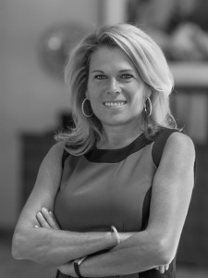

Donna Hilfiger

Donna Hilfiger has studied personal development for over 26 years. She is an international speaker. In the past year she has spoken at events in Australia, Switzerland, Austria, Germany and France. She is the former Host of Life Coach Radio, she has been featured on The Secret To Life Coaching TV Show as well as a regular guest on Global Television Network in Washington DC, President of The Cole Spencer Foundation and owner of DCH, Inc. With her experience as a Master Hypnotherapist, an Elite Master B.E.S.T Practitioner, Donna has developed LASER VISION in being able to identify and remove blocks that are holding people back from living the life of their dreams! Based on tangible results and feedback from client testimonials Donna creates life-changing results with anyone she comes into contact with. Whether you are in the room with Donna or miles away on the telephone, Donna’s energy hits the core of who you are and challenges you to dig deep and make the changes you desire! When she is not running around the country teaching, you can find her on the beach or her boat with her husband and 5 children.

Meet Commissioner Schultze
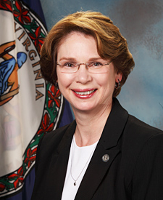Commissioner Margaret Ross Schultze
The Virginia Department of Social Services touches the lives of thousands of individuals and families in the Commonwealth. Margaret Ross Schultze is committed to ensuring that many of Virginia's most vulnerable residents have access to the services and benefits available to them.
Her experience in state government began in 1997. As director of the gubernatorially appointed Family and Children's Trust Fund, Margaret Schultze raised resources — and awareness — for the prevention and treatment of family violence, including child abuse and neglect, domestic violence, sexual assault, and elder abuse. Her tenure with FACT led to increasingly responsible roles within the Department culminating in her current position as Commissioner.
Ms. Schultze oversees both programmatic and administrative functions within the Virginia Department of Social Services. VDSS is one of the largest Commonwealth agencies, partnering with 120 local departments of social services, along with faith-based and non-profit organizations, to promote the well-being of children and families statewide.
A native of Roanoke, Virginia, she graduated from Hollins University (formerly Hollins College) with a Bachelor of Arts in Biology and a teacher certification. Prior to her work in human services, she was the Director of Financial Aid for Roanoke College. Margaret and her husband live in Midlothian.
Meet your presenters:

Joyce Allen, IT Inventory Control

Michelle Atkinson, TANF/VIEW Consultant, VDSS

Denise Avent, is a retired CPS social worker from Greensville/Emporia DSS. She is currently employed with Gatten Behavior Health were she facilitates classes in anger and stress management, parenting and self-esteem.
Tonia Baker, Human Resources Manager
Angie Beachy, Director of Change Management, angela.beachy@dss.virginia.gov, (804) 726-7365
Bruce Blizard, Test Manager, Division of Enterprise Systems, Robert.blizard@dss.virginia.gov
Shel Bolyard-Douglas, Director of Prince George Social Services and the 2nd Vice President of the Virginia League of Social Service Executives, Shel.Bolyard-Douglas@dss.virginia.gov (804)733-2650
Nancy Branch, Business Analyst, Division of Enterprise Systems, VDSS
Elnetta Burke, Member Financial Services, Virginia Credit Union
Sheryl Carter-Thompson, Business Analyst, Division of Enterprise Systems, VDSS
Lisa Colandene-Noiri, SNAP Consultant, Northern Region, VDSS
Christopher Coley, Project Manager, Division of Enterprise Systems, Christopher.coley@dss.virginia.gov, (804) 726-7828
Nikole Cox, SNAP Program Manager, VDSS
Sandra Davis, Business Analyst, Division of Enterprise Systems, VDSS

Mahalia “Mally” Dryden-Mason has been a part of the Department of Professional and Occupational Regulation’s Virginia Fair Housing Office since 2003. During the twelve years of working as the Fair Housing Training Specialist, she has taken what many felt was a mundane and boring subject and turned it into a very sought after topic of discussion, with her energetic style presentations that are both informative and interactive. “Knowledge of the Fair Housing laws is essential to every person. When robbed of the right to buy or rent housing that an individual qualified for, it can be a devastating experience to many victims.”

Valerie Dunbar, MA, Family Services Specialist- VIEW Program, Chesterfield- Colonial Heights DSS

Cassandra Elliston, TANF/VIEW Consultant, Piedmont Regional Office, 540-204-9645, Cassandra.elliston@dss.virginia.gov

Pamela Giles, Human Resource Manager

Mark Golden, TANF Program Manager, VDSS

Victor Grand, Senior Contract Manager with CoverVa.

Andrea Gregg, Energy Assistance Program Manager, VDSS

Tim Grothaus is an associate professor and graduate counseling program director in the Department of Counseling and Human Services at Old Dominion University. He received a Ph. D. in counselor education from the College of William & Mary in 2004 after serving over 20 years as a school counselor, teacher, therapist, coordinator of a youth leadership development program, and youth minister.

Carolyn Hammock, BPS IV, Prince Edward DSS, Carolyn.hammock@dss.virginia.gov

Yolanda Hardy, Manager, Program Integrity Division, Department of Medical Assistance Services, (804) 588-4879, Yolanda.Hardy@dmas.virginia.gov

Donna Harrison, Department of Corrections

Brian Hawkins, Fatherhood Manager of FIT (Fathers in Training) VA Beach DSS

Gail Heath-Davidson, MSW, CPS Senior Regional Consultant, Eastern Region
Burnette Hendricks, SNAP Consultant, Eastern Regional Office, (757) 552-1881, Fax (757) 552-1832, burnette1.hendricks@dss.virginia.gov
Janice Holmes, Program Manager, DMAS, Maternal and Child Health Division, (804) 225-4280 (office) (804) 382-0126 (cell)

Natalie Jay-Short, Trainer & Instructor III VDSS

Patricia Jones-Turner is involved in many aspects of the community, in her job as the Domestic and Sexual Violence Coordinator for Chesterfield County since 2004 and offering her gifts and talents as a minister.

She also served as a trainer for the Virginia Institute for Social Services Training Activities at Virginia Commonwealth University’s School of Social Work where she provided statewide training and curriculum development to social workers in the field of domestic violence and sexual assault for over six years.

Reverend Jones- Turner has been an educator for 15 years including athletic trainer and coach in the states of Virginia, Delaware, and North Carolina. She has been a social worker for 23 years.

Stephanie Larson, Assistant Director, Change Management Office, Stephanie.larson@dss.virginia.gov, (804) 726-7031

Bonnie Lee, SNAP Consultant, Piedmont Regional Office, VDSS
David Leon, Ticket to Work Coordinator, Grants & Special Programs, Virginia Department for Aging and Rehabilitative Services, 8004 Franklin Farms Drive, Richmond, VA 23229, NEW EMAIL: David.Leon@dars.virginia.gov, (office) 804-662-7151, (fax) 804-662-7683,
Susan Lloyd, Fraud Consultant, Fraud Management, VDSS, susan.lloyd@dss.virginia.gov, 804.726.7682

Denise Lucombe, MSW, MA, Family Engagement/TDM, Richmond DSS
Monique Majeus, Business Analyst, Division of Enterprise Systems, Monique.majeus@dss.virginia.gov (804) 726-7453
Steve McCauley, IT Services Manager
Debbie Miller, Medical Assistance Program Consultant debbie.miller@dss.virginia.gov, (804) 726-7013

Donna Montgomery, Benefit Programs Trainer, Roanoke County DSS, dmontgomery@roanokecountyva.gov, 540-283-8829

Mone’t Murray, Henrico Department of Human Services, mur039@henrico.us
Stephanie Napper, Test Manager, Division of Enterprise Systems, Stephanie.napper@dss.virginia.gov (804) 726-7959
Chartoya Newton, Medical Assistance Program Consultant, chartoya.newton@dss.virginia.gov, (804) 726-7377

Karen Packer, DMAS

Joy Patton, TANF/VIEW Consultant, Western Regional Office, joy.patton@dss.virginia.gov (276) 676-5486

Natalie R. Pennywell, MPH, CHES currently works as a Community Health Educator for the Virginia Department of Health, Crater Health District which includes eight localities and seven health departments. Ms. Pennywell is afforded the opportunity to plan, support, conduct, and evaluate community health needs assessments; district health education, promotion, and prevention grant activities and proposals; and data regarding the district’s health status. Ms. Pennywell spends the majority of her work collaborating, engaging, supporting, training and helping to sustain community organizations and coalitions working with each other and the health department to improve the health and wellbeing of the citizens in the district and across the state. She also manages/coordinates the Healthy Living and Learning Center in the Petersburg Public Library. She received her Bachelor of Science degree in biology with a minor in chemistry from Voorhees College in 2006 and her Master of Public Health in health promotion, education, and behavior from the University of South Carolina in 2010. She holds certifications as a Certified Health Education Specialist (CHES) and a Consumer Health Information Specialist (CHIS).
Kevin Platea, Technical Program Director Division of Enterprise Systems, VDSS
Cynthia Powell, SNAP Consultant, Central Region, (804) 662-9776
cynthia.powell@dss.virginia.gov

Jeff Price, DSS, DataWarehouse, jeff.price@dss.virginia.gov

Carey Raleigh, Adult Services/Adult Protective Services Program Consultant, DARS

Stephanie Sivert, Medical Assistance Program Manager, VDSS

Melissa Smith, Department of Justice

Myra Smith, Department of Corrections

Thomas (Skip) Steinhauser, Director, Benefit Programs, VDSS

Dorrie Thompson, TANF/VIEW Consultant, Eastern Regional Office, 540-347-6327, dorrie.thompson@dss.virginia.gov

Debra Travis, TANF/VIEW Consultant, Central Regional Office, 804-662-9747, debra.travis@dss.virginia.gov

Deborah Vaughn, Business Program Director, Enterprise Delivery System Program Office, VDSS, (804)726-7793 (office), deborah.vaughn@dss.virginia.gov

Mary Ward, Child Care Subsidy Manager
Toni Washington, Project Manager, Division of Enterprise Systems, toni.washington@dss.virginia.gov (804) 726-7662
Rick Waugh, Human Services Supervisor, Henrico County Social Services, 8600 Dixon Powers Dr., P.O. Box 90775, Henrico Virginia 23228, Phone:(804) 501-4990, Fax: (804) 501-4006
wau016@henrico.us
Dottie Wells, Division Director-Strategy Management and Research, Division of Enterprise Systems, dottie.wells@dss.virginia.gov (804) 726-7639
Phillip White, Senior Family Services Specialist, Henrico DSS

Geraldine Winnegan, Benefits Specialist, Richmond DSS

Otissa Williams, Family Services Worker Prevention Team, Richmond DSS

Chris Woodbury works for the Virginia Credit Union, which is one of the 70 largest credit unions in the country. Chris’ currently works in the Membership Development Department with a concentration in providing financial services and literacy programs for Selected Employee Groups, State Agencies and Local Governments, and Communities for the state of Virginia. With more than 20 years’ experience in the financial services industry, Chris has held several positions in retail and commercial banking; – Branch Manager, Staff Trainer, Quality Assurance Manager and Loan officer. Chris is a passionate advocate for financial literacy. Chris believes the “Best Financial Decisions are Informed Decisions.” Chris.Woodbury@vacu.org

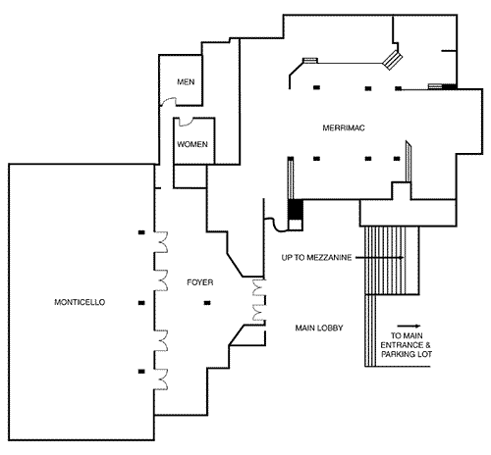

First Floor Function Space

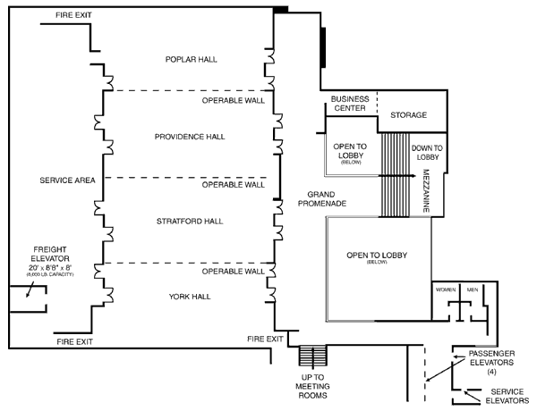

Third Floor Function Space

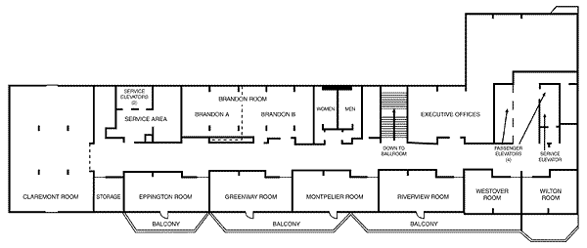
Fourth Floor Function Space

