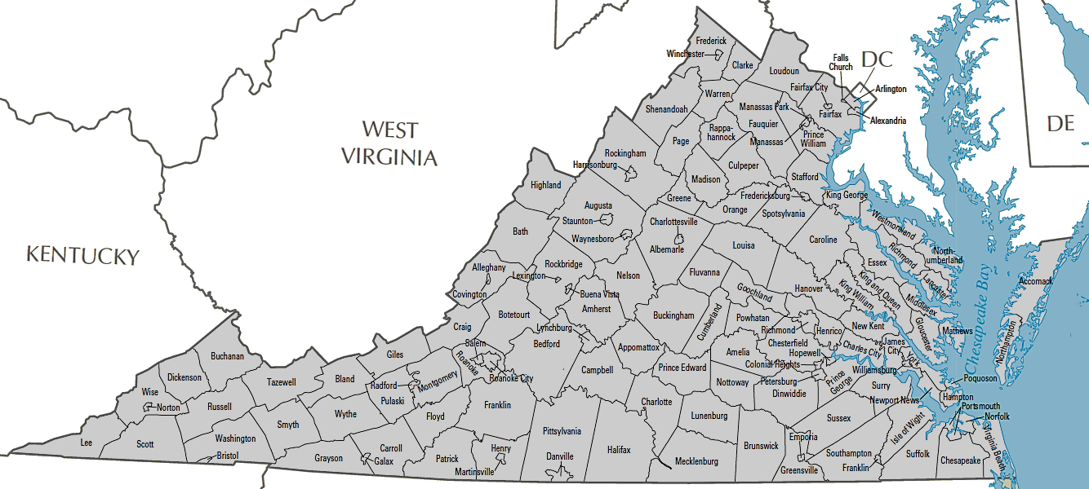
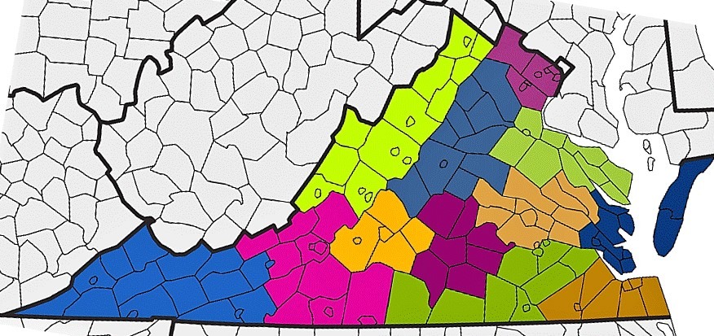
8

16 & 17
9 & 10
6 & 7
15
21 & 22
14
11
20
5 & 12
1 & 2
13 & 19

Planning District | 1& 2 | 5 & 12 | 6 & 7 | 8 | 9 & 10 | 11 | 13 & 19 | 14 | 15 | 16 & 17 | 20 | 21 & 22
Member Localities | Bland  Bristol  Buchanan  Carroll  Dickenson  Galax  Grayson  Lee  Norton  Pulaski  Radford  Russell  Scott  Smyth  SWVSHI  Tazewell  Washington  Wise  Wythe | Botetourt  Craig  Danville  Floyd  Franklin (County)  Giles  Henry/Martinsville  Montgomery  Patrick  Pittsylvania  Roanoke (County)  Roanoke (City) | Alleghany  Bath  Clarke  Frederick  Harrisonburg/Rockingham  Highland  Page  Rockbridge  Shenandoah  Shenandoah Valley  Warren  Winchester | Alexandria  Arlington  Fairfax  Loudoun  Manassas  Manassas Park  Prince William | Albemarle  Charlottesville  Culpeper  Fauquier  Fluvanna  Greene  Louisa  Madison  Nelson  Orange  Rappahannock | Amherst  Appomattox  Bedford  Campbell  Lynchburg | Brunswick  Dinwiddie  Greensville/Emporia  Halifax  Hopewell  Mecklenburg  Petersburg  Prince George  Surry  Sussex | Amelia  Buckingham  Charlotte  Cumberland  Lunenburg  Nottoway  Prince Edward | Charles City  Chesterfield  Colonial Heights  Goochland  Hanover  Henrico  King and Queen  New Kent  King William  Powhatan  Richmond (City) | Caroline  Essex  Fredericksburg  King George  Lancaster  Northumberland  Richmond (County)  Spotsylvania  Stafford  Westmoreland | Chesapeake  Franklin (City)  Isle of Wight  Norfolk  Portsmouth  Southampton  Suffolk  Virginia Beach | Accomack  Gloucester  Hampton  James City  Mathews  Middlesex  Newport News  Northampton  York/Poquoson  Williamsburg
Virginia Benefit Programs Organization Planning District Map & List of Planning District Member Localities

