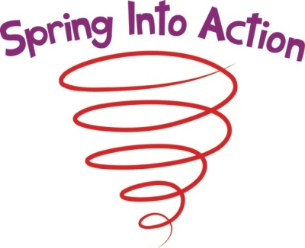

Rooms starting at $87 per night!!!

https://www.starwoodmeeting.com/Book/SPRINGINTOACTION
Click the link above to make your reservations TODAY!!!
(or copy and paste into your web browser)
OR you can give them a call at 757-622-6664
Be sure to mention that you are with the BPRO, POSSESS, VASWP Conference
Registration costs:
Full Registration = $100
1 day Registration= $65
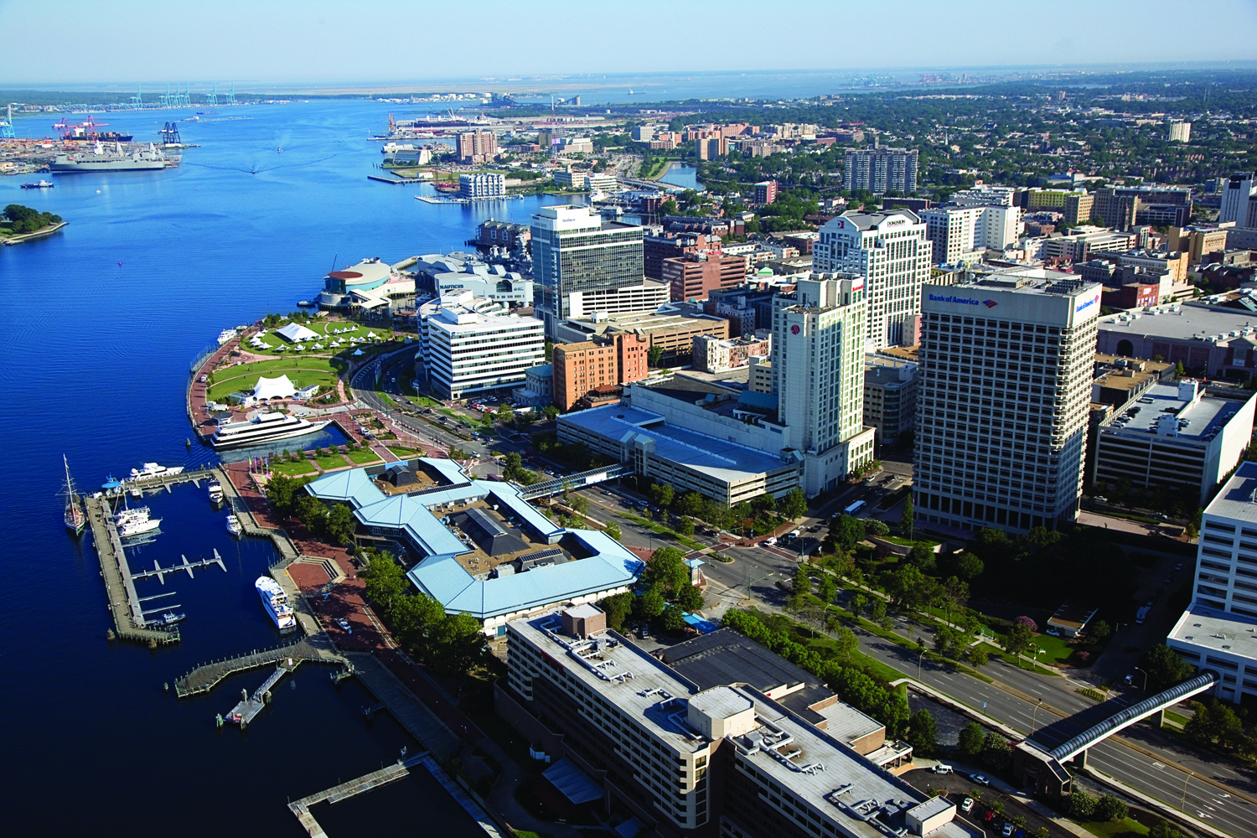
April 29-May 1 2015
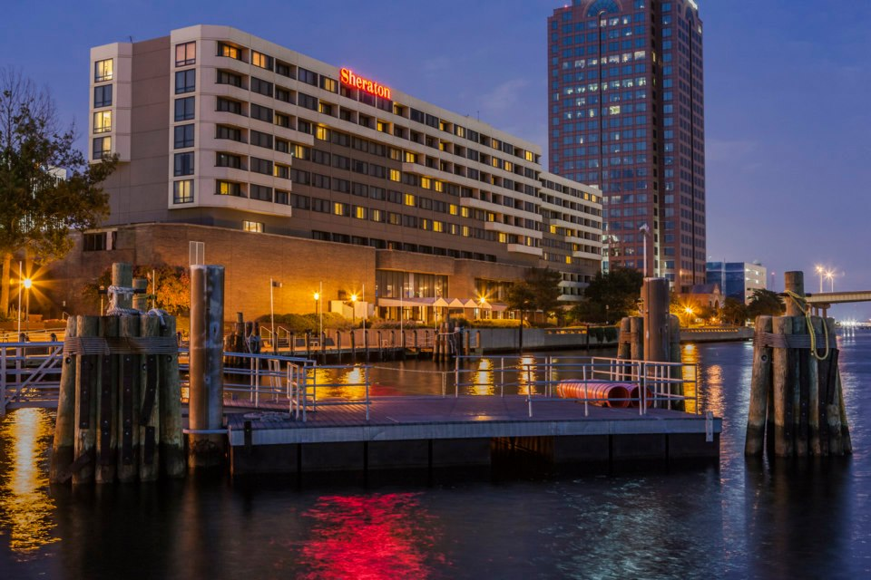
This could be you!!

