2015 Spring BPRO- POSSESS -VASWP Conference

Wednesday, April 29, 2015 Tentative Workshops:

8:00 am Registration Begins * Child Care What the Future Holds
* TANF Is My Case Correct
9:00 am Pre-conference workshops *LTC, What is it; Special Rules; Q&A
*Energy-Cooling
12:15 Lunch (provided) *Energy-Reports
*Enrollment in MMIS
1:30 pm Welcome & Keynote Speaker *Working with VIEW & Child Care *Working with DCSE
3:15 pm Workshops *Motivational Interviewing
BPRO Business Meeting *Career Development for VIEW
POSSESS Business Meeting *Job Search for 21st Century
*IV-E
*ABAWD
*SNAP Q&A
Thursday April 30, 2015 * Adult Services
*Reentry-Family Reunification
7:00 am Breakfast (provided) *CPS 2015
*VIEW- Let’s Get Engaged
9:00 am Workshops * Medicaid Appeals
VASWP Business Meeting *Extended Medicaid
*Preparing Cases for Migration
10:45 am Workshops *Round Table Discussion-Front
Office Best Practices
*Getting it Right from the Start
12:15 Lunch (provided) *Human Resources
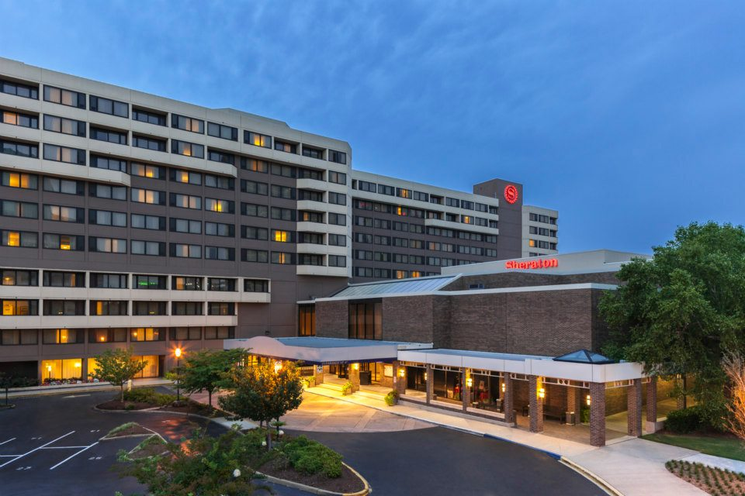
1:30 pm Workshops *VaCMS

3:15 pm Workshops
BPRO Business meeting

Friday May 1, 2015

7:00 am Breakfast (provided)

9:00 am Workshops
Benefits Panel
10:45 am Workshops

Photo compliments of www.visitnorfolk today.com

HOTEL ACCOMODATIONS:
Sheraton Norfolk Waterside Hotel
777 Waterside Drive
Norfolk, VA 23510

Reservations must be made by 4/1/2015 by using the code: BPRO, POSSESS, VASWP Conference (OR copy and paste the following link into a web browser) https://www.starwoodmeeting.com/Book/SPRINGINTOACTION
Parking: Valet Parking onsite $24.00/day
Discounted parking garage at Dominion Tower Building $5.00/day
City Parking Lot 1/8th of a mile (not covered) Free

2015 Spring BPRO- POSSESS -VASWP Conference

Conference Registration:

Early Registration: $100 members, $120 non members postmarked until March 13th
Regular Registration: March 14th-April 1st $110 members, $120 non members

**All BPRO Scholarship Recipients and PD Presidents, Executive Board and Committee Chairs must pay a $20 administrative fee. Please indicate Scholarship or Board position on your registration**

Please Print or Type:

Name:

Position:

Agency/Fips:

E-mail:

Address:

**BPRO Scholarship recipient or Board position:

Send Registration form & Payment to:

BPRO: POSSESS: VASWP:
(make checks to BPRO) (make checks to POSSESS) (make checks to VASWP)

Tina Caldwell-Eheart Ann-Marie Giannini Renee White
Charlottesville DSS Northern RO (FIPS 995) Henrico County DSS
PO Box 2967 410 Rosedale Court #270 P.O. Box 90775
Charlottesville, VA 22902 Warrenton, VA 20186 Henrico, VA 23273
434-970-3679 540-347-6308 804-501-5866
(Do Not Pouch Registration)

*****REGISTRATION DEADLINE IS April 1, 2015***********

You must complete one day or three day registration form in order to attend the conference. Securing a room does not complete the conference registration requirement.

Attendee once your registration and payment is received and verified you will receive a confirmation letter.

Note: Any registration received after this date will NOT be guaranteed printed conference materials. You must contact your organization for registration approval after deadline.

2015 Spring BPRO- POSSESS -VASWP Conference

**ONE DAY REGISTRATION FORM FOR THURSDAY April 30, 2015**
Registration Fee: $65.00 includes conference materials

Please Print or Type:

Name:

Position:

Agency/Fips:

E-mail:

Address:

Parking Fee: Valet Parking onsite $14.00/day
Discounted parking garage at Dominion Tower Building $5.00/day
City Parking Lot 1/8th of a mile (not covered) Free

Send Registration form & Payment to:

BPRO: POSSESS: VASWP:
(make checks to BPRO) (make checks to POSSESS) (make checks to VASWP)

Tina Caldwell-Eheart Ann-Marie Giannini Renee White
Charlottesville DSS Northern RO (FIPS 995) Henrico County DSS
PO Box 2967 410 Rosedale Court #270 P.O. Box 90775
Charlottesville, VA 22902 Warrenton, VA 20186 Henrico, VA 23273
434-970-3679 540-347-6308 804-501-5866
(Do Not Pouch Registration)

*****REGISTRATION DEADLINE is April 1, 2015*****

Attendee once your registration and payment is received and verified you will receive a confirmation letter.

Note: Any registration received after this date will NOT be guaranteed printed conference materials. You must contact your organization for registration approval after deadline.

